Dear Y1 Fir
How are you all? I really hope you’re coping ok at home. I know that this feels like a really strange time. We all enjoy our holidays, but by now I think everybody will be starting to get a bit bored. I know I am!
So I thought we could all share some of the things that we’ve been doing. I’ve used the time that I have to try some new things. So far I have:
- Done lots of cooking and baking, finding new and exciting recipes to try.
- Looked after my pet guinea pigs, and let them have fun playing in the garden. They love to explore and to eat the grass and dandelions that they can find (as you can see).
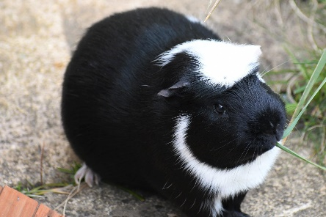 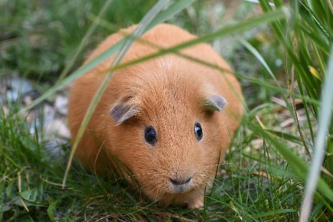
- Done lots of gardening, taking the weeds out of my strawberry and raspberry plants ready for them to start growing again.
- Finished reading one book and started my second.
- Practising using my camera, by taking photos of the birds in the local area from my garden and on my allowed daily walk.
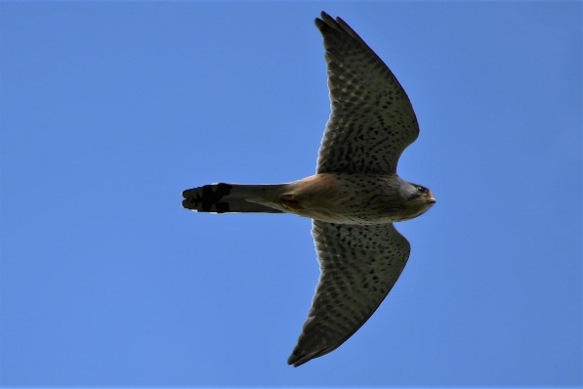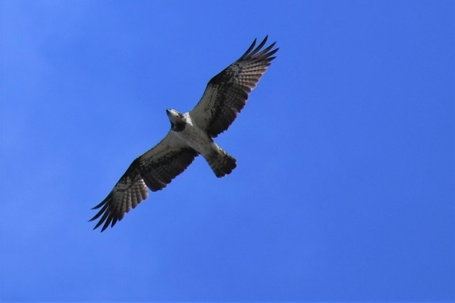
I’m going to be setting some work for you to do at home this week. It would be great for you to do as many as you can. You can send anything work that you’re proud of to this email address: y1fir@astreabyronwood.org
You can also send photos or videos of anything else that you do to the same address. I can’t wait to see what you’ve been up to! Hopefully, I’ll be able to share some on the class’ page on the school website so that you can all see what each other are doing.
Look after yourselves. Remember that staying with your families at home, and only going outside with them for some short exercise, is the most important thing you can do right now, even if it is difficult sometimes.
I look forward to hearing from you all.
Mrs Russell and Ms Grace

