Hi Y4 Maple,
I hope you’re all doing okay and staying safe. This is a very strange time and hopefully it will pass soon. I hope you all enjoyed your Easter holidays, but by now I think everybody will be starting to get a bit bored. I know I am!
I thought I would share the things that I’ve been doing. I have used the time that I’ve got to try some new things. So far I have:
- Done a lot of gardening and have been feeding our local grey squirrel!

- I have been doing Joe Wicks daily workout (which has been hard at times!) https://www.youtube.com/user/thebodycoach1
- I have been taking part in weekly quizzes over video chat with friends and I have even made my own quiz!
- With the extra time, I have been doing lots of cooking and baking
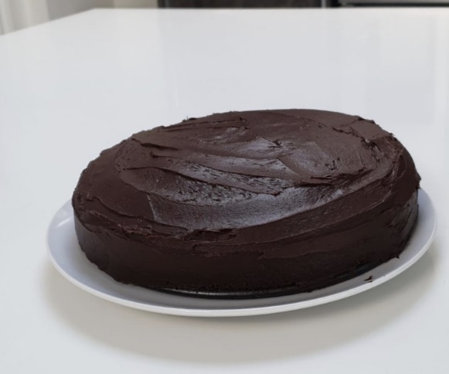
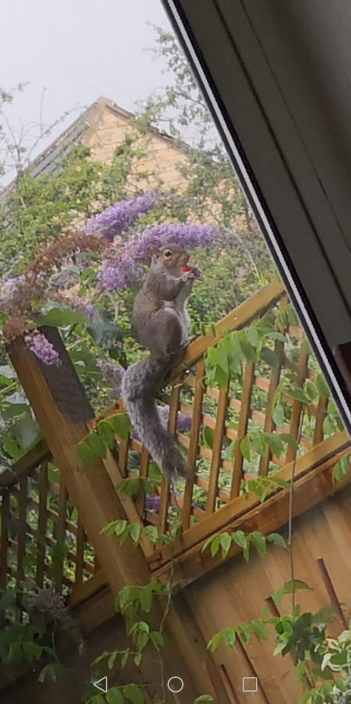
Here is a picture of a chocolate cake that I was very proud of. Great British Bake Off – here I come!
It’s a bit tricky to get a photo of the squirrel! We need to give him a name, have you got any suggestions?

If you’re running out of things to do, have a look at this list below:
- Drawn some comics
- Take a picture of the local wildlife near you
- Go out for a walk or cycles (make sure its only for an hour)
- Done some exercise every morning. My favourites have been
PE With Joe Wicks - https://www.youtube.com/user/thebodycoach1
and Cosmic Kids Yoga - https://www.youtube.com/user/CosmicKidsYoga
- Make a collage of old wrapping paper/gift bags

As well as these challenges, I’m going to be setting some work for you to do at home this week. It will help if you could do some of the questions that I’ve set for you. I would love to see any pictures of any work that you are proud of. Hopefully, I will be able to share some your work on the school’s website and you can share with your friends.
Remember, make sure that you are staying with your families and only going out for a daily 1 hour exercise a day. Look after yourselves and your loved ones, it is the most important thing we can all do right now during these hard times.
I am looking forward to seeing and hearing from you all soon.

Miss Fadra

