Hello Chestnuts!

I hope you have all been enjoying some time away from school and staying safe indoors with your families? So far it has felt a bit like a holiday at my house but now everyone is starting to get a bit bored!

I have enjoyed spending time with my children and we have been busy doing lots of things we don’t usually have time for: we have made Easter nests (yum!) and homemade pizza, planted lettuces and spotted amazing butterflies and birds.

We have also been trying to get some exercise by going for walks near our house (remembering to stay more than 2 metres away from other people!), doing yoga (https://www.youtube.com/channel/UC5uIZ2KOZZeQDQo_Gsi_qbQ), keeping fit with PE with Joe (https://www.youtube.com/user/thebodycoach1) and doing obstacle courses in the garden! What have you been doing to keep fit?

We have also read lots of amazing books, done jigsaws, played games together and done some artwork to celebrate the NHS who are helping to look after so many sick people. Have any of you made a rainbow for your window/doorstep?

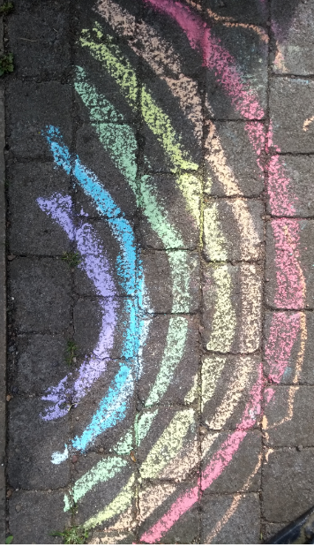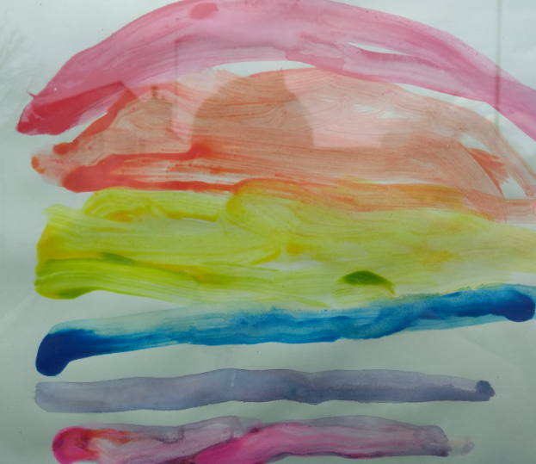

This week I will be putting some work up on the website for you. I know it is difficult to concentrate on schoolwork at home, but it is important to keep learning and it could help the time to go faster!

You can send in any work you are proud of and pictures of what you have been doing to this email address: Y4Chestnut@astreabyronwood.org

I hope we will be able to share our pictures and work soon on our class page of the school website.
In the meantime, look after yourselves and remember to stay safe and indoors with your family!

Mrs Southwood

