Dear Y1/Y2
I hope you are all ok and having fun at home. I thought I would share some of the things that I have been doing.
I have enjoyed spending lots of time with my family. We have been going for a walk every day and have discovered some woods near our house which my children have loved playing in! We have done nature trails and found some interesting mini beasts and plants.
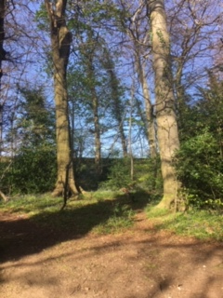
We have also been doing lots of cooking and baking and made some delicious chocolate cakes over the Easter weekend!
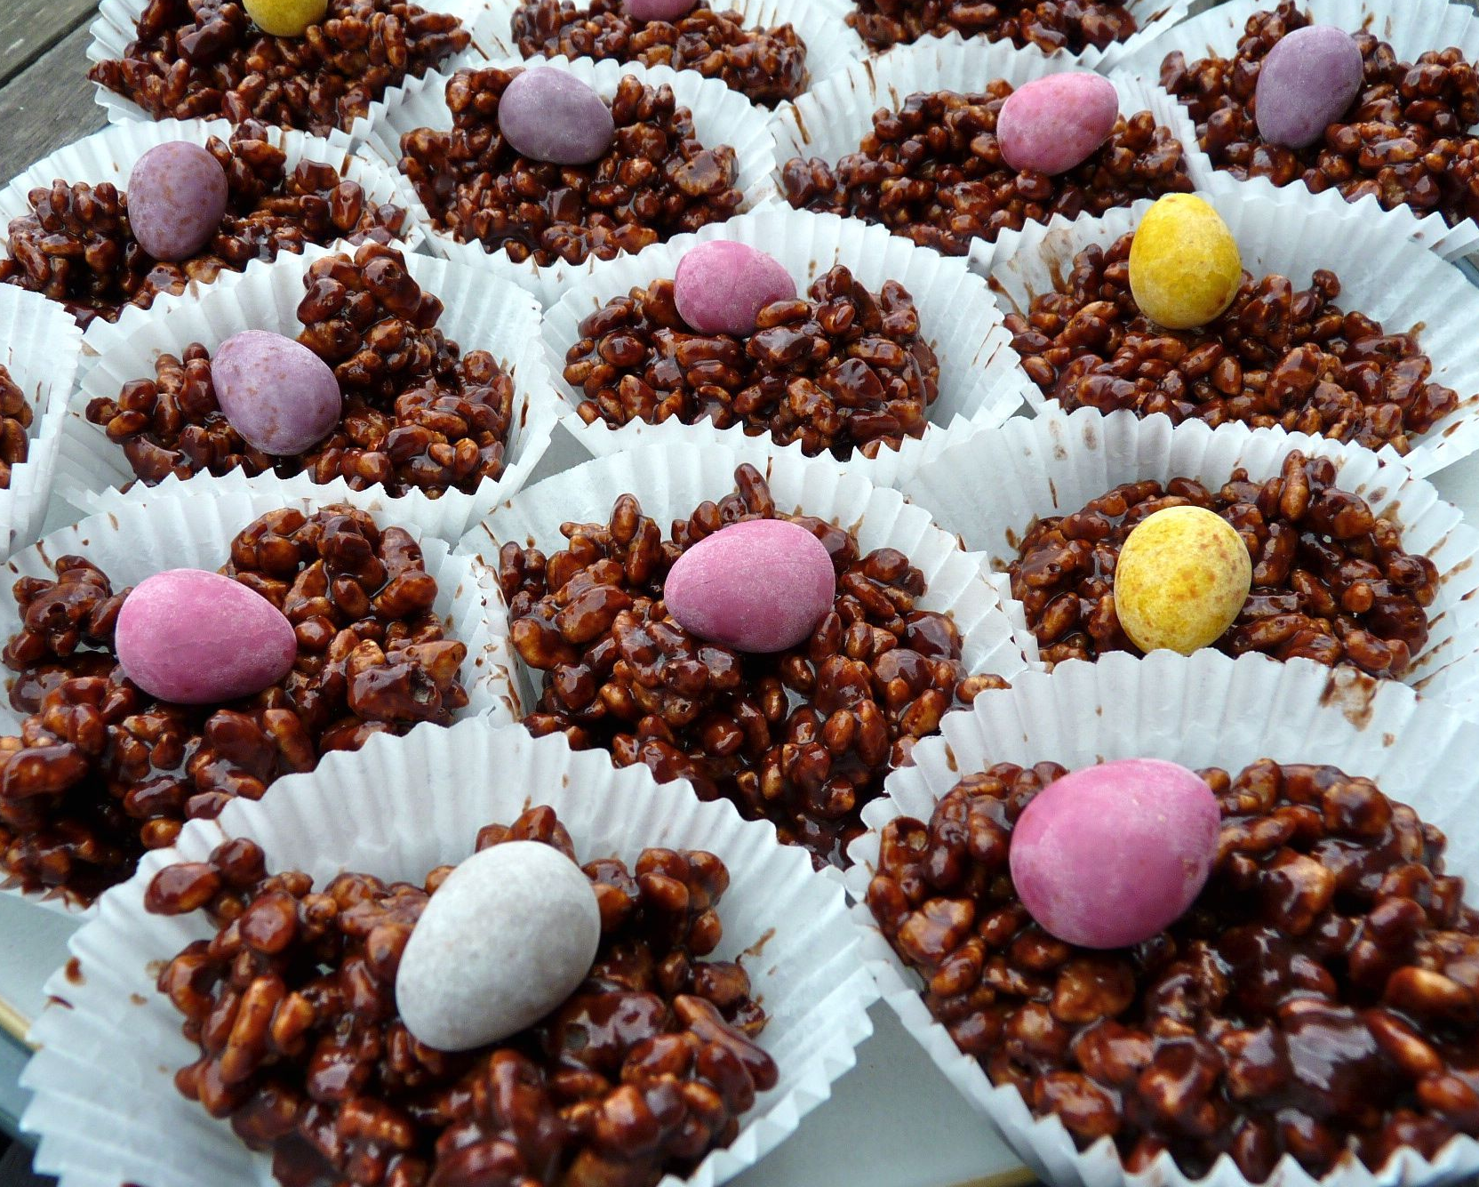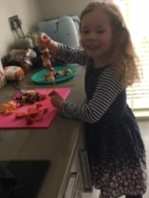
I have also been gardening with my children and we have planted some new flowers and herbs which we are looking forward to seeing grow.
My little girl loves art so we have done lots of drawing, painting and creative activities, including making animal masks, flowers and elephants! I would love to know what creative activities you have been up to.
You and your families are doing really well by staying at home and only going for a walk once a day. Well done to all of you and I hope you enjoy completing the new home work on the school website this week!
From
Mrs Davies

