Y4 HOME LEARNING – Tuesday 2nd June 2020

Grammar task: Suffix

A suffix is a letter or a group of letters that can be added to the end of a word to change its meaning.
Watch this short clip to learn about the -ous suffix and how it is used.

https://www.bbc.co.uk/bitesize/articles/zr8kwty

Adding the suffix -ous turns a noun into an adjective. It means 'full of'.
For example: Dangerous means 'full of danger'.
- Underline the suffix in each of these words

- fabulous b) famous c) horrendous
d) jealous e) dangerous f) enormous

- Draw a line to match each word to its correct meaning
Known about by many people
fabulous

Feeling resentment for what other people have
Extremely unpleasant
The biggest thing around
Risky, could cause harm
Extraordinary, great
enormous
dangerous
horrendous
jealous
famous

- Can find your own word with the suffix –ous and write their meaning.
CHALLENGE: Write the words you have found in your sentence!

Maths – Tuesday 2d June
Multiplying Three Numbers
This looks tricky but is actually really easy when you break down the steps:

For example:
2 X 5 X 4 =
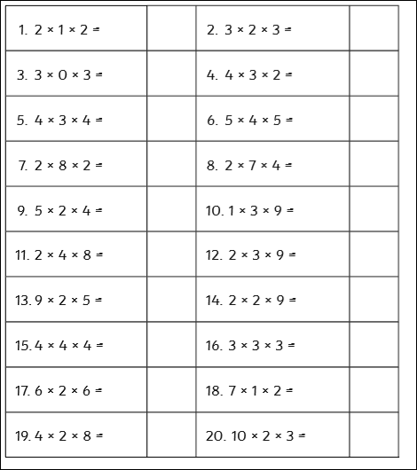
2 X 5 = 10 then 10 X 4 = 40

Creative task – Tuesday
Rocket man
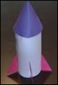

Get a plastic bottle and turn it into your very own rocket! Use any scraps of paper or cardboard to help you make the wings. See what things you can use around the house to make your bottle look more rocket shape. We’d love to see videos of you trying to get it fly!
We’d love to see your work, so please email us:
Y4maple@astreabyronwood.org
Y4chestnut@astreabyronwood.org

