Y4 ANSWERS – Tuesday 19th May 2020

1. Complete the phrases:

An adverbial adds extra information about where, when or how

A fronted adverbial goes at the front of the sentence.

A fronted adverbial is always followed by a comma.

2. Underline the adverbials in the sentences below. Use red for adverbials that tell you where, blue for adverbials that tell you when and green for adverbials that tell you how.

1. He threw the ball against the wall.
2. Finally, the plane landed at the airport.
3. An enormous boat sailed along the Mersey.
4. After completing the race, Jasmine felt tired.
5. The girl jumped on the trampoline like a yo yo.
6. Exhausted, he climbed into bed.

3. Use the word mat on the next page to add an adverbial or a fronted adverbial to each sentence below. Try to use at least one where, when and how adverbial
Example Answers
- Like floating feathers, the snow fell all morning.
- Feeling annoyed, Fred opened the front door.
- The family chatted to each other during the meal.
- Sarah looked up from her work with a sigh.
- The children could hear the birds singing whilst walking along.
- Silently, the cat pounced on the bird.

Tuesday – Maths Tasks Answers
Subtracting Decimals
Keep the decimals in a line
Start from the smallest value
If the number is a smaller value than the top number, then exchange
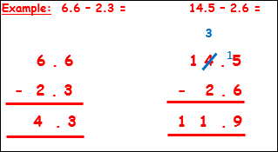

Questions
- 4.9 – 1.5 = 3.4
- 5.5 – 2.7 = 2.8
- 6.3 – 3.5 = 2.8
- 13.5 – 2.9 = 10.6
- 16.7 – 3.8 = 12.9
- 22.3 – 3.9 = 18.4

- 7.6 – 2.5 = 5.1
- 9.9 – 3.5 = 6.4
- 14.5 – 3.4 = 11.1
- 9.8 – 4.7 = 5.1

