Y4 HOME LEARNING – Wednesday 13th May 2020

Writing task: Adverbials

1. Watch this short film about birds on a wire: https://www.youtube.com/watch?v=2VyPPDpT2xU`

2. Now look at these pictures from the film. For each picture, write a sentence describing what is happening. Then use an adverbial or fronted adverbial to add more information about where, when or how.
You can use the word mat from yesterday’s task to help you or you can try the challenge task on the next page. The first one has been done for you.

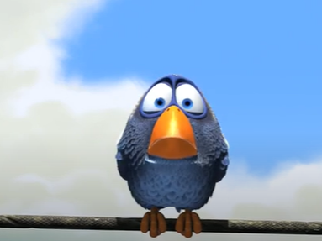
A bird landed on a telephone wire.

After a long flight, a bird landed on a telephone wire.

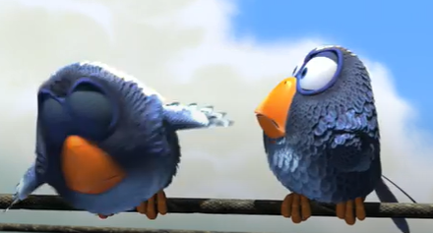

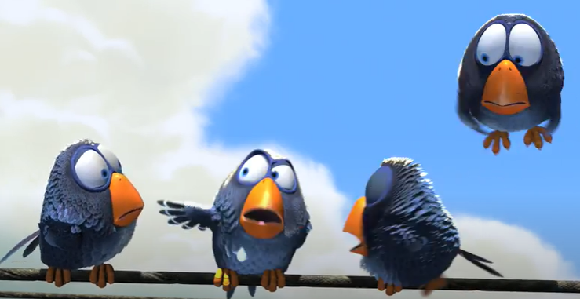

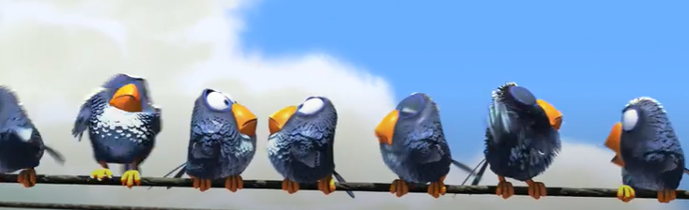

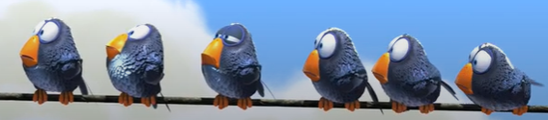

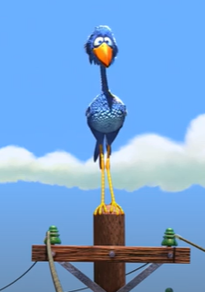

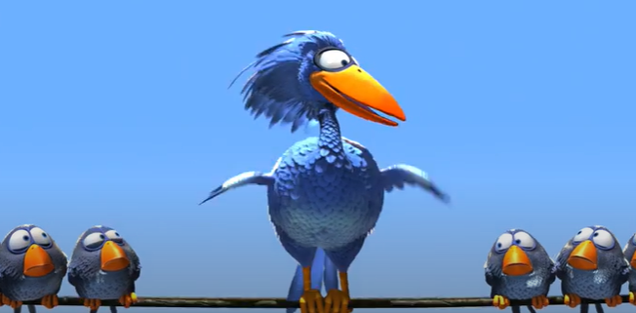

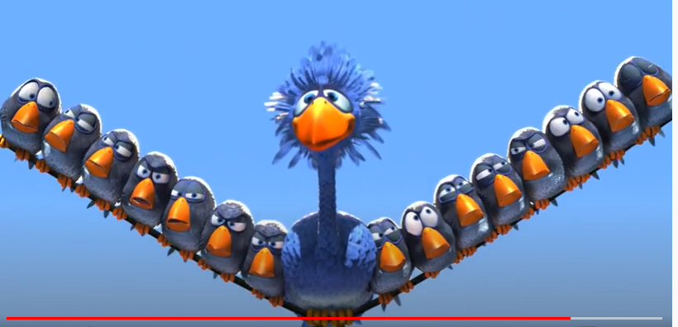

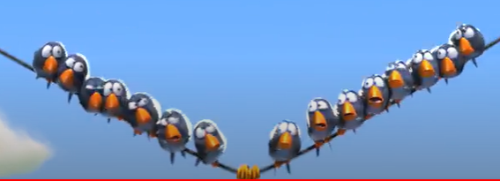

Don’t forget to send your work to your teacher: Y4Chestnut@astreabyronwood.org or Y4Maple@astreabyronwood.org

CHALLENGE: Can you make fronted adverbials in more interesting ways? You can use the word ISPACE to help you:

I - ing word (Looking tired, Feeling annoyed, Wearing a raincoat)
S – simile (Like a rocket, As quick as a flash, As soft as a feather)
P- preposition (With a sigh, Over the rooftops, during the meal)
A - adverb (Quickly, Noisily, Suddenly, Surprisingly)
C – conjunction (After eating quickly, Whilst walking along)
E - ed word (Exhausted, Surprised, Worried)

Maths Tasks
Place value - Decimals
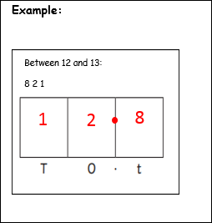
Arrange all the digits to make a decimal numbers.

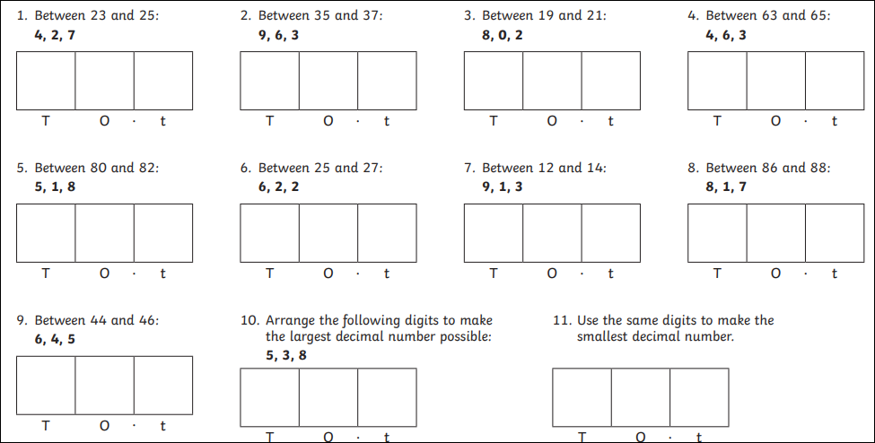
Questions:

Creative Activity – Wednesday
Household Treasure Hunt
Have fun exploring your home and create your own treasure hunt. Draw a map and then hide various items around the house and get your little ones to hunt them down. They can then draw their own maps of the house, or a room, and hide an item in which you have to find.
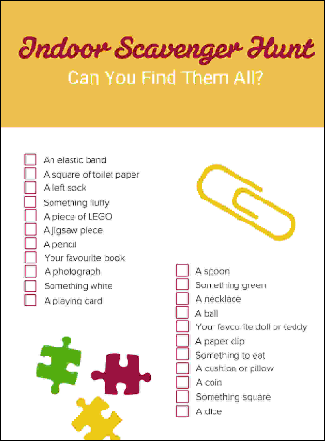
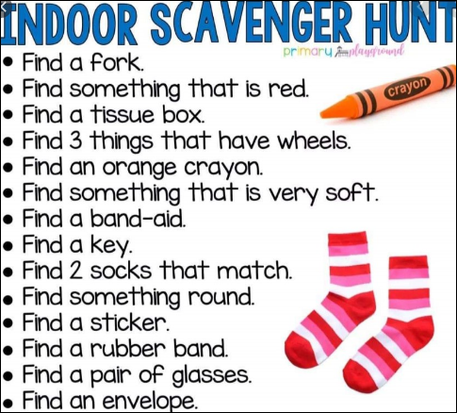
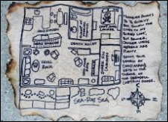
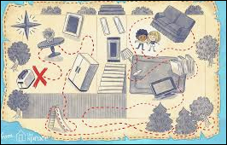

We’d love to see your work, so please email us:
Y4maple@astreabyronwood.org
Y4chestnut@astreabyronwood.org

