Y4 HOME LEARNING – Friday 22nd May 2020

Comprehension Task

Read the reading task from yesterday, answer the questions below. Make sure you keep using the text to help you find the answers.

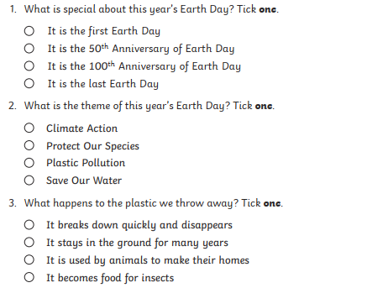
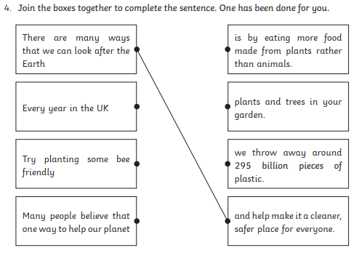
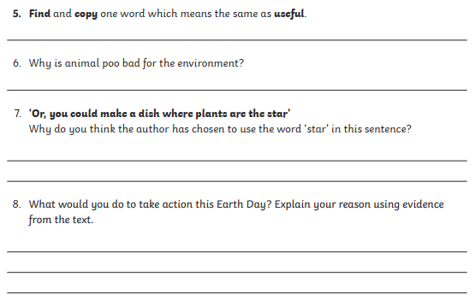

Friday – Maths Tasks
Money - Decimals
Keep the decimals in a line
Start from the smallest value
Make sure you carry any tenths.

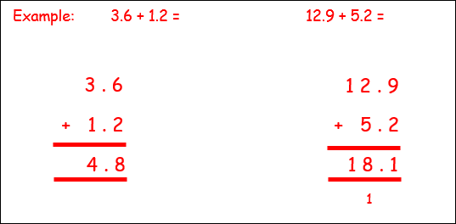

1) £13.59 + £48.05 =
6) £245.27 + £9.59 =
7) £45.94 + £99.09 =
8) £24.50 + £12.09 + £34.75 =
9) £8.65 + £312.50 + £23.97 =
10) £24.50 + £12.09 + £34.75 =

2) £68.60 + £27.98 =
3) £22.89 + £9.16 =
4) £56.80 + £62.75 =
5) £123.65 + £83.06 =

Creative Activity – Friday
Send a postcard
Make a postcard or letter and write a special note to them and post it to a friend or family member.
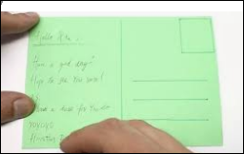
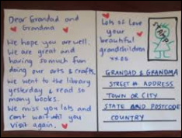

We’d love to see your work, so please email us:
Y4maple@astreabyronwood.org
Y4chestnut@astreabyronwood.org

