English – Beegu
Last half term we read the story ‘Beegu’, about an alien who crashed onto planet earth. Watch this video of the story:
https://www.bing.com/videos/search?q=beegu&docid=608032154669285508&mid=058991483BEBCE2B7A76058991483BEBCE2B7A76&view=detail&FORM=VIRE
Task One
Now, can you answer the following questions about the story:
- Who did Beegu try and talk to?
Beegu tried to talk to…
- What did she think was her mother calling her?
She thought that the _____________ was her mother calling her.
- Who did Beegu make friends with first?
Beegu made friends with…
- What did Beegu do in the playground?
In the playground, Beegu…
- How did Beegu get home at the end of the story?
At the end of the story…
- Who did Beegu think was friendly in the story?
In the story, Beegu thought that…

Task Two - Thinking task
If you landed on a new planet, who or what would you miss the most and why?
If I were an alien, I would miss __________ the most because…

Maths
Today I would like you to look at the connections between number bonds to 10 and number bonds to 20. Remember, you can use your number bonds to 10, to help you to make a number bond to 20 by adding 10 more to one of the numbers. Here is an example:
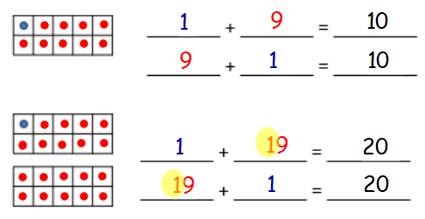
Here is one number bond for 10 and 20. In each of these, one part is 1. When making 10 the other part is 9 and when making 20, I add another 10 and the other part is 19.
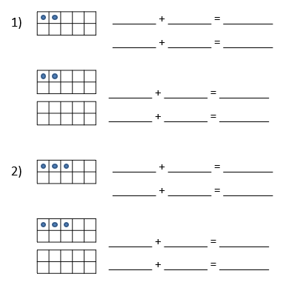

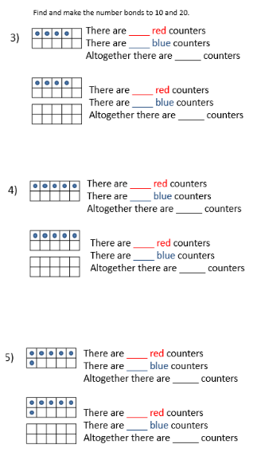
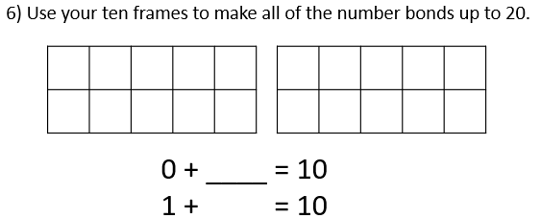

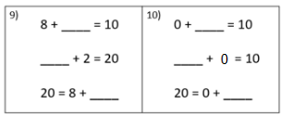
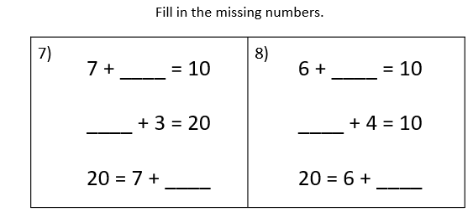

Challenge:
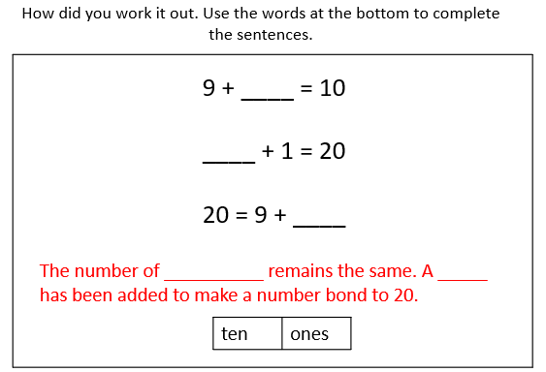

Creative
Today we would like you to have a go at making an elephant from a milk carton. Do you know which continents elephants live in?
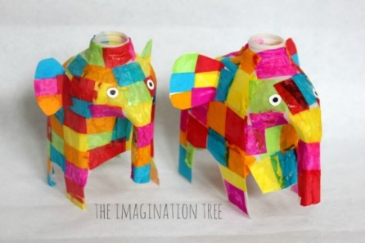
You will need:
- 1 empty and clean milk jug container
- scissors
- brightly coloured tissue paper cut into equal size squares (use paper from magazines or leaflets if you haven’t got tissue paper).
- glue
- white card
- black pen
- Or googly eyes if you have any

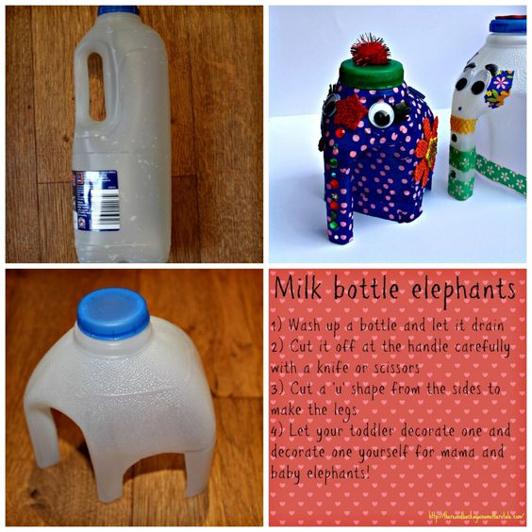
How to make it:
- Cut the bottom off the milk carton,
starting below the handle.

- Cut a ‘u’ shape from the sides to make the legs.

- Stick squares of paper to cover all the plastic.

- Stick on some eyes above the trunk.

- Cut out some ears from the rest of the milk carton and stick on the side of the head.

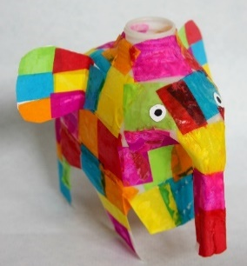

Weekly Project work - Continents
This week, we would like you to explore the different continents around the world. We have some key questions that we would like you to explore and find information on.

A continent is a group of countries (large are of land) that is surrounded by water.
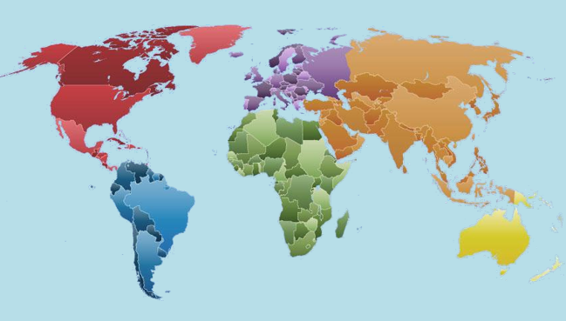
Task One
What are the names of the 7 continents and where on they on a world map? If you want a challenge, can you identify which continent we live in? Are they any other countries you can locate in the continents as well?
Task Two
Can you find out about an animal that lives in each of these continents? You may want to draw a picture of that animal, create a fact file or even a short video showing us what you have learnt.
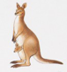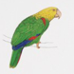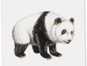
Here are some websites you may find useful:
https://www.google.com/earth/
https://www.topmarks.co.uk/Search.aspx?Subject=12&AgeGroup=2
https://www.bbc.co.uk/bitesize/clips/zjtmhyc

