Monday 11th May 2020
English Task.
Change the underlined words to make the sentences better.
- The boy was sad.

- “Oh no!” said Sophie.

- The small, black dog was outside.

- They were walking past the green trees.

- The girl was happy because she had a sticker.

- It was cold outside.

- The dog was black.

- The tall man had hit his head on the roof.

- The sandwich was nice.

- The sun was yellow.

Maths task.
Partition numbers
Partition these numbers into hundreds, tens and units
Example 237 = 200 + 30 + 7
- 587
- 469
- 132
- 987
- 366

What number has been partitioned?
Example 700 + 60 + 7 = 767
- 400 + 30 + 6 =
- 200 + 50 + 8 =
- 600 + 10 + 1 =
- 900 + 80 + 2 =
- 100 + 20 + 6 =

Extension
- 3,468 =
- 8,125 =
- 6,000 + 200 + 10 + 9 =
- 1,000 + 0 + 0 + 1 =

Creative task.
Monday’s challenge = Arty Hands!
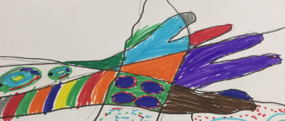

Draw around your hand.
Now divide your outline into different sections.
Use different colours and patterns in each section.
Turn your hand into a work of art!
Enjoy and have fun

Weekly topic investigation.
- Read the information below.
- Label the pictures correctly.
- Tell me what you have discovered about these items from your reading.

