Wednesday 13th May 2020
English task.
Using the conjunctions, continue the below sentences.
- Yesterday, I went outside in the garden because….

- On Monday I will have swimming so ….

- Molly wanted fish and chips for dinner whereas….

- The dog was barking for his owners since ….

- The monster was hiding in the corner and ….

Choose a conjunction and continue the sentences below:

- The trees were swaying in the forest.

- The penguin was swimming in the water.

- Harry needed his coat.

- People live differently now compared to in the Stone Age.

- The pyramids of Egypt are magnificent.

Maths task.
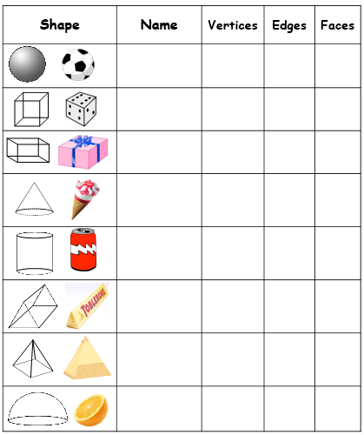

Creative task.
Wednesday’s challenge = Rocketman!

Get a plastic bottle and turn it into your very own rocket!
We’d love to see videos of you trying to get it fly!

Enjoy and have fun

