Y4 HOME LEARNING – Thursday 25th June 2020

Reading Task
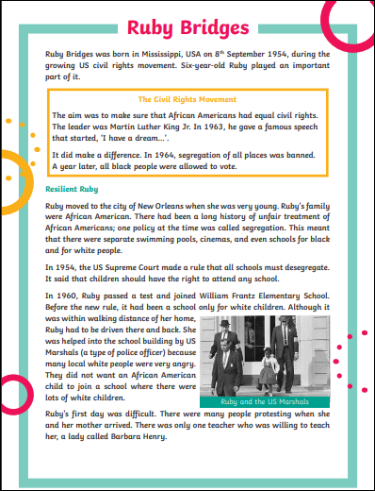
Practice reading it out loud, then time yourself – how far can you get in a minute?
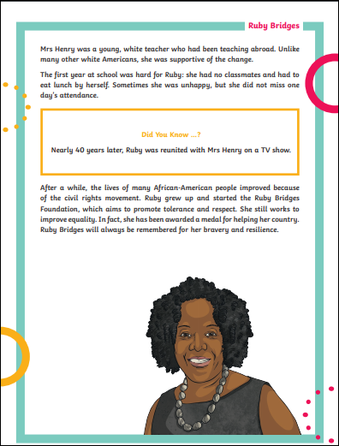

Maths – Thursday 25th June 2020
To find equivalent fractions
Equivalent fraction have the same value:

=
_2_
4
_1_
2

_3_
4

_6_
8

_9_
12

When you multiply or divide both the top and bottom by the same number.
Whatever you do to the bottom, you must do to the top.
Tip: Use your timetables knowledge to help!

Your Activity:
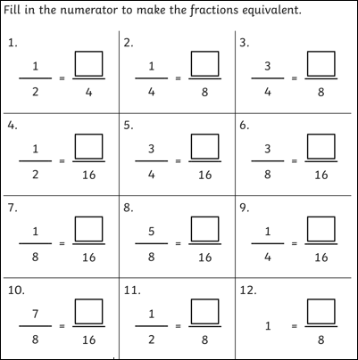

Creative Activity – Thursday
Easy Playdough

Playdough is another old favourite and can keep them entertained for hours. Whether they want to make their own dinosaur, elephant, car or castle, the possibilities are endless. If you can manage not to stress about the colours being mixed together it can be a whole lot of fun. And if you haven't got any Playdough it's pretty simple to make your own.
All you need is:
- 2 cups of plain flour
- 1 cup of salt
- 1 tablespoon of oil
- half to 1 cup of cold water
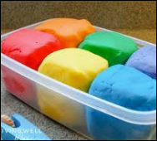
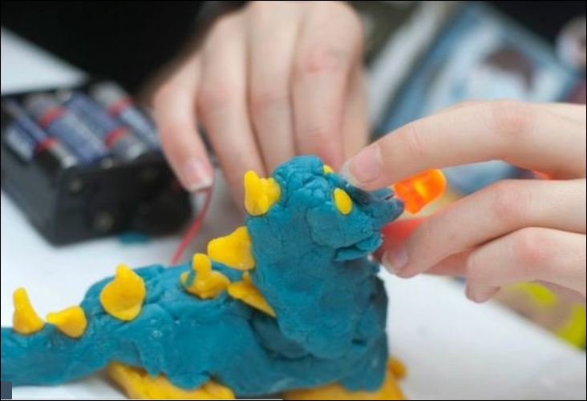
- 2 drops of liquid food colouring

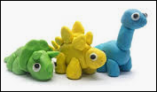
Mix the flour and salt then add the water, oil and food colouring. Knead the mixture well, adding a little more flour if the consistency is too wet.

We’d love to see your work, so please email us:
Y4maple@astreabyronwood.org
Y4chestnut@astreabyronwood.org

