Y4 HOME LEARNING – Thursday 2nd July 2020
Reading task:
Practice reading it out loud, then time yourself – how far can you get in a minute?
age, gender and family relations.
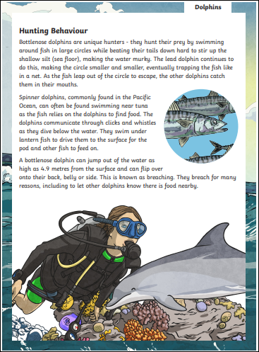

Maths – Thursday 2nd July 2020
Roman Numerals
Here are three letter used to show numbers:
I = 1 V = 5 X = 10
If a larger Roman Numeral is followed by a smaller one, you add the two together
XI = 10 + 1 = 11
VI = 5 + 1 = 6
If a smaller Roman Numerals is followed by a larger number, you must subtract the smaller number from the larger number
IX = 10 – 1 = 9
IV = 5 – 1 = 4

What are the values of these Roman Numerals?

II = VII = XXI = IX =
XI = XV = XIX = XXIII =
XXIX = XXV = XXIV = XIV =

Write these numbers in Roman Numerals:

6 = 17 = 26 = 11 =
30 = 29 = 3 = 23 =

Challenge: Solve these Roman Numerals number sentences, you can write the answer in Roman Numerals or regular numbers.

X + VI = XV - V = IV + VI =
XIX + III = XXV - VII = XIV + VI =

Creative Activity – Thursday
Sketching

Have a go at sketching the picture below or choose your own picture.

We’d love to see your work, so please email us:
Y4maple@astreabyronwood.org
Y4chestnut@astreabyronwood.org

