English – writing instructions
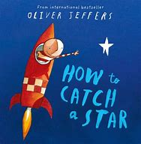
Yesterday, you began drawing the steps for each of your instructions for the boy to reach the new star in the sky, now we are going to write the instructions so that the boy can get to it in his new rocket that you have designed. Remember, a good set of instructions need:

- Imperative verbs at the start of an instruction to tell us what to do. e.g. Spread the butter on the bread.
- Time adverbials which tell us the order the instructions are in e.g. first, after, last
- Clear, simple instructions that can be followed easily

Task – complete your set of instructions
You need to use your pictures to write the steps in the boxes underneath. I hope your instructions are clear and specific so that the boy can find even more stars in the sky to add to his collection!

Picture
Instruction

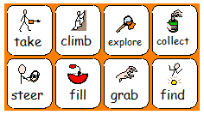

Maths
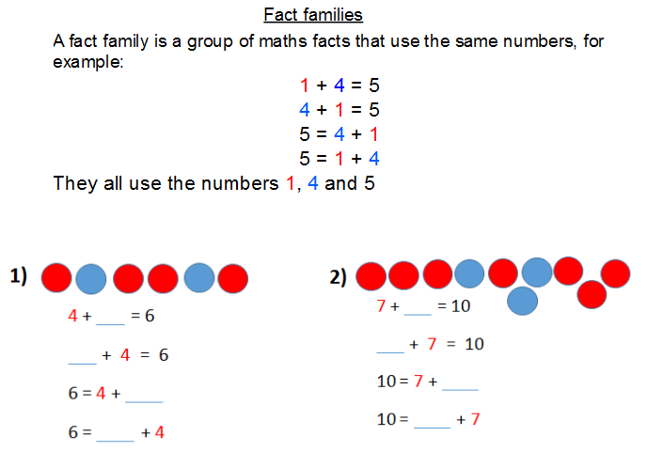
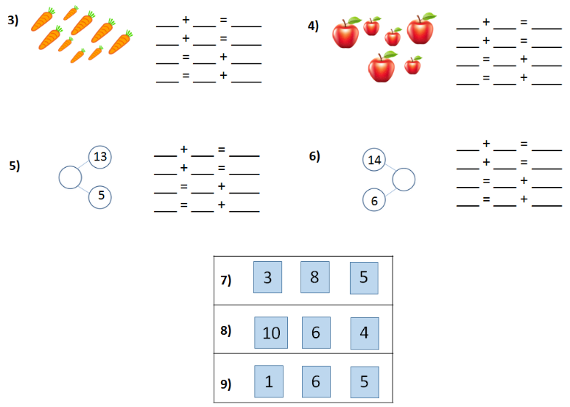
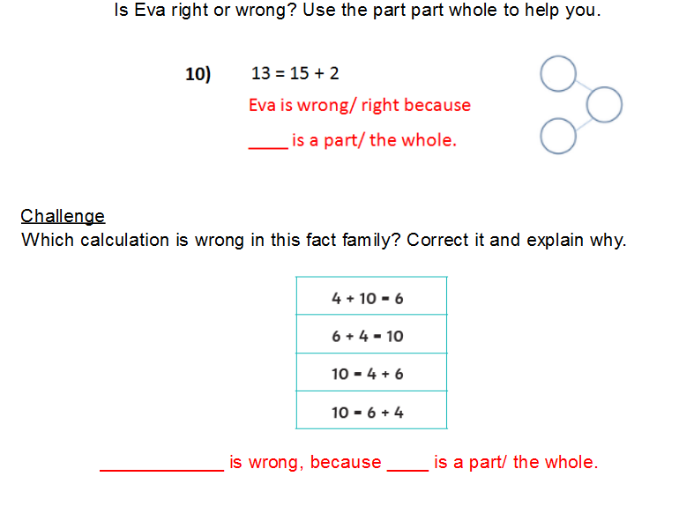

Creative
This week you have made a star mobile, a rocket, some moon cakes and a spaceship.
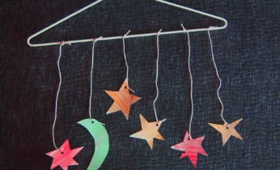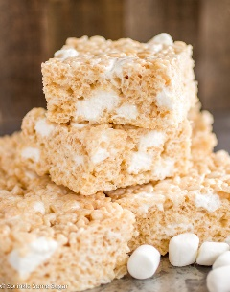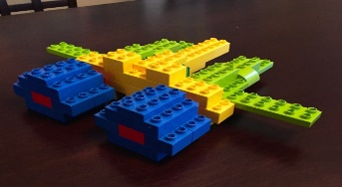
Today we would like you to think of your own space story and act it out using the things you have made.

Think of your story first.
- Who are the characters?
- Where do they live?
- What happens in the story?
- How does the story end?

Can you tell us about your story? You might even want your grown up to film your story. Don’t forgot to email it to us!

Weekly Project work

Light
Some objects make and give out light, and these objects are called light sources. A lamp is an example of a light source you may find at home.
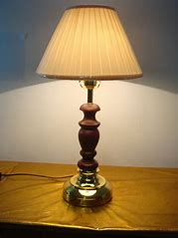
What other light sources can you find? Are there any in your house? Can you find any on your daily walk?

Shadows

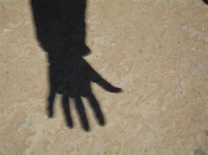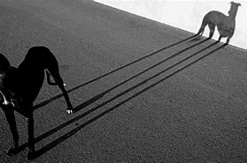

A shadow is created when light is blocked by an object. If you stand in front of a light source, a shadow will be created.

Can you find some shadows when out on your walk? Can you create shadows using items you have at home? Can you make a shadow puppet and perform a short story?

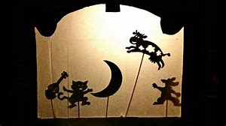
Send some pictures of the shadows that you have found and made!

