Friday
English
Read this final passage from The Hodgeheg and answer the questions:
Never, for the rest of her life, did the lollipop lady forget the sight that now met her eyes. Coming along the pavement towards her were seven hedgehogs in single file.
‘Surely you’re not going to school?’ said the lollipop lady when they reached her.
The noise she made meant nothing to Max, but he advanced to the edge of the kerb, his nose pointing eagerly across the street, the others lined up behind him.
‘We wish to go the Park,’ he said. ‘Kindly stop the traffic.’ The noise he made meant nothing to the lollipop lady, but his intention was as clear as the day. Raising her magic wand on high, the great female strode into the middle of the street and at the sight of her the traffic meekly halted.
Then, before the astonished eyes of those fortunate enough to witness this historic occasion, there walked across the street a slow, solemn dignified procession – of hedgehogs.
At the rear was Uncle B, shepherding before him Peony, Pansy and Petunia. In front of them was Ma. In front of her was Pa. But at the head of the file there marched that pioneer of road safety, Victor Maximillian St George, a name to be remembered forever by hedgehogs the world over.

‘Tell us the story of the First Crossing, Mummy,’ little hedgehogs would plead at bedtime, and then they would listen, enthralled, to the tale of Max, the hedgehog who became a hodgeheg who became a hero. Always the mothers ended with the same words: ‘…and they all crossed happily ever after!’

- Why didn’t the lollipop lady ever forget what she saw?
- What does single file mean?
- Why did she ask if the hedgehogs were going to school?
- Why does it say, ‘The noise she made meant nothing to Max’?
- What does meekly mean?
- Why were the drivers ‘astonished’?
- Why will Max’s name be remembered by hedgehogs?
- What happened to turn Max the hedgehog into a hodgeheg?
- Which famous story ending does the end of this book remind you of?
- What was your favourite part of the book? Why?

Maths
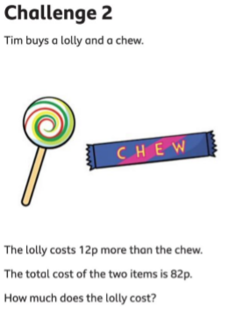
Year 3 Maths Challenges
Friday
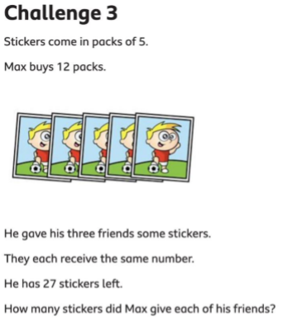
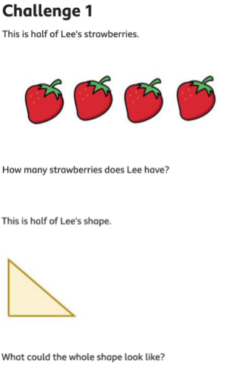

Each day, I will give you half of a famous picture. I would like you to finish off the other half, copying the style of the artist as best you can.
Creative Challenge!
Today: Water Lilies, by Claude Monet
