English – exploring the story
This week, we will be exploring a book called ‘The Odd Egg’ by Emily Gravett.
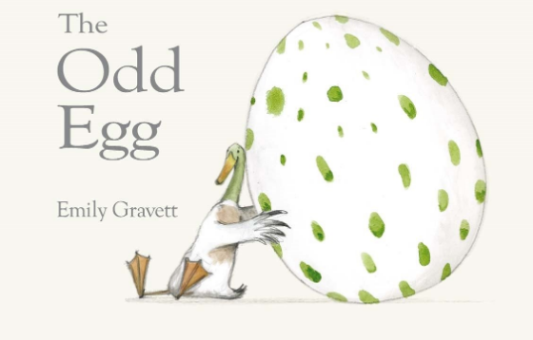
Talking task
What do you think this story may be about?
I think that the story may be about…because….

Task One

On the front cover of the book, there is an egg. Some animals hatch from eggs. Have a little look at the video to see a few tiny creatures. There are lots more that you can fine. Have you got any pictures in books at home or other videos you have watched?

https://www.youtube.com/watch?v=WDGMUDoGgOk

Which animals do you now know hatch from eggs? Write four sentences/examples.
I know that a ________ hatches from an egg.

Task Two

I want you to make predictions about which animal may hatch from this egg and why. Think about the video we have watched, and the size and colour of the egg on the front cover. You may have a few different ideas, so may want to write more than one prediction!

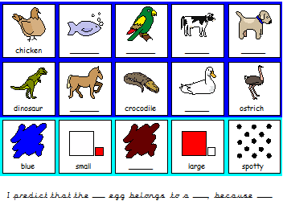

Maths
Today we are going to continue working on our number bonds to 20 (finding all the different ways that we can make 20). Find all of the number bonds to 20. Represent them on the ten frames.
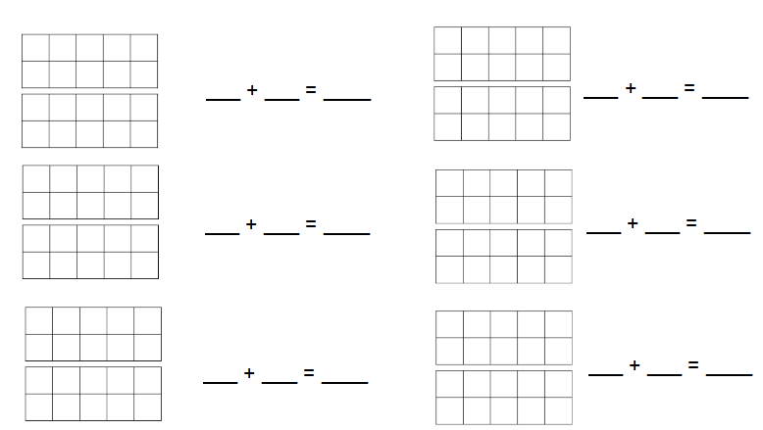
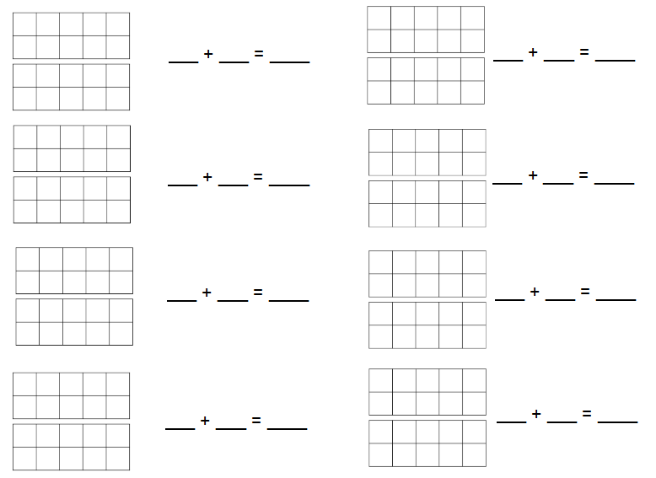

Challenge
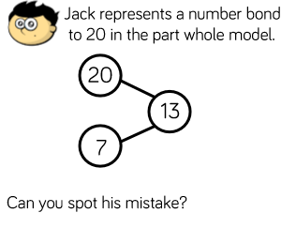
Jack’s part part whole shows that the number _____ is a part/ the whole, but it should be a part/ the whole.

Creative
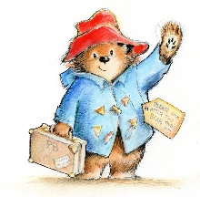
This week is international refugee week. Do you know Paddington Bear? Paddington lived in the jungle in Peru. One day there was a huge fire that destroyed his home. With nothing left and nowhere to go, Paddington was forced to make a difficult journey to London, stowed away on a lifeboat in the hope of a better life.
When Paddington arrived, London was not as welcoming as he had expected. He was ignored by almost all passers-by until the Brown family kindly offer him a place to stay.

Today we would like you to sketch a picture of Paddington Bear. Watch the video below:
https://www.youtube.com/watch?v=wcu8-tKAYh0

You will need a piece of paper and a pencil. Don’t forget to do gentle strokes with your pencil when you sketch. Don’t press too hard.

Weekly Project work

The Four Seasons

We have learnt about the four seasons in Science this year: Spring, Summer, Autumn and Winter. Watch the video and discuss what you can see happening. Are there any changed in the weather? What is happening to the plants?

https://www.bbc.co.uk/teach/class-clips-video/the-changing-seasons/zh4rkmn

Task One
Draw a picture to represent each of the four seasons. Think about the colours you will use, what the weather will be like and what will/will not be growing at that time of year. Can you name each season and write a short caption underneath about what you may see.

Draw a picture and name the season.

Write a description of what you may see.
Task Two
Which season is it currently? I would like you to carry out an experiment and monitor the weather for the next week. You could complete the table below, or create one of your own.
I would also like you to find out how much it rains each day/if it rains during this season. Can you get a measuring jug and put it outside every day. The next morning, you can look at how much rain there has/has not been and record it in the table.

Day | Monday | Tuesday | Wednesday | Thursday | Friday
Weather
Amount of rain
Description

How much rain have you collected today?
Draw a picture of the weather

