English
On World Book Day, we read the story ‘The Giant Jam Sandwich’. Have a listen to the book again to familiarise yourself with what happens:
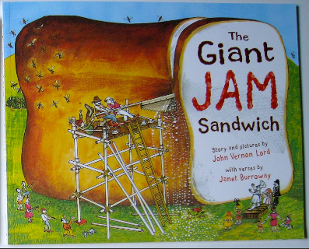
https://www.youtube.com/watch?v=2-HjO3P_IXs
Task
Can you answer these questions about what you have read?
- What is the name of the town in the story?
The name of the town is…
- How many wasps flew into the town?
______________ wasps flew into the town.
- Where did the wasps sting Lord Swell?
The wasps stung Lord Swell on …
- What do wasps like to eat?
Wasps like to eat…
- What did the villagers use to pull the sandwich into the giant oven?
The villagers used…
- How many cookers were in the old brick mill oven?
There were…
- What did they use to slice the bread?
They used…
- Why didn’t they use the village bus to take the sandwich to the field?
They didn’t use the bus because…
- What did they do with the second slice of bread after the wasps came?
The villagers…
- What did the villagers do at the end to celebrate?
The villagers…

Maths

Place value – look at the tens and ones and write the numeral.

- = _________

- = _________

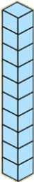
- = ___________
Write the numerals for these amounts

= ___________

5.
= ____________

6.
= _________

7.
= _________

Tick the correct representation
8. Which shows 14?
a)
b)

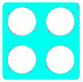

_____ shows 14 because it has ____ tens and ____ ones.

9. Which shows 19?
a)
b)

_____ shows 19 because it has ____ tens and ____ ones.

10. Can you represent 17 in different ways?
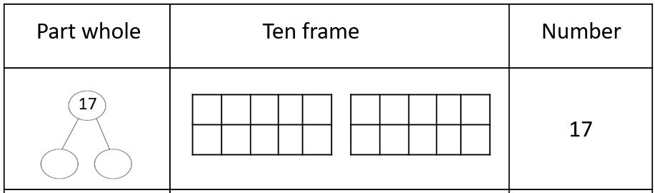

Creative
I have been spotting lots of minibeasts in my garden and local woods. Minibeasts are small creatures like worms, snails, insects and spiders. They are invertebrates, which means they do not have a back bone. Have a look at the minibeasts below and see how many you can find in your garden or local area. Write a list of all the minibeasts you see.

Weekly Project work – Bubbles
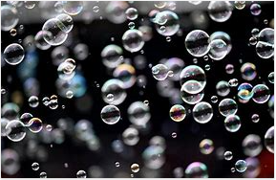

This week, I want you to explore bubbles. Can you make your own bubble wand at home?
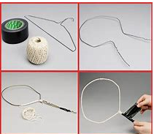
Try using:
- Pipe cleaners
- Sticks and coated wire
- Sticks and string
- Cookie cutters and sticks

To make the bubble mixture, you will need:
- 1litre of hot water
- 250ml washing up liquid
You could make different colours using food dye!

Exploration task linked to Science
With your bubbles, I want you to investigate the following:
Can you make bubbles with just water?
Do bubbles last longer in the shade or the sun?
Do bubbles make shadows?
Do bubbles last longer on a dry surface or a wet surface?
Can bubbles go underwater?
Are smaller or bigger bubbles stronger?
Could a person float in a bubble? Why/why not?

