English – exploring the characters
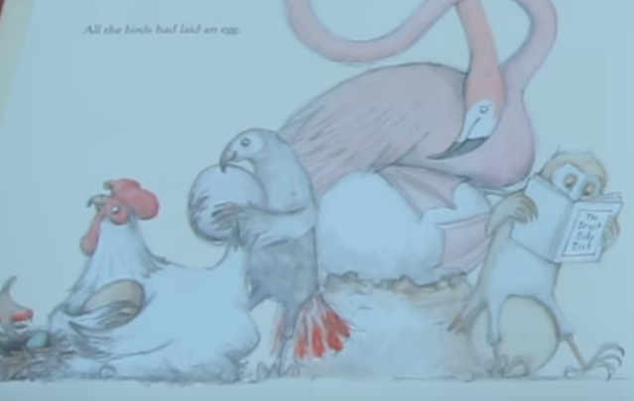
Talking task
At the start of the story, there are different animals holding eggs. Discuss which animals you can see.
I can see…

Task One – sentence work
In this picture, the characters are holding an egg. I want you to have a think about what each of these characters are thinking. They may be thinking about their egg, their feelings or they may have a question they want to ask.
Can you complete these thought bubbles for the animals in the picture from the book.

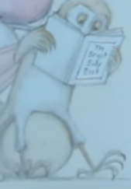
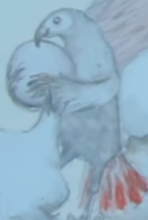
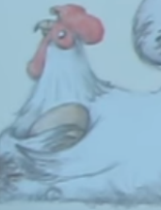
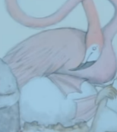
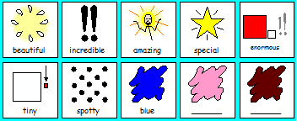
I feel …
I hope that…
My egg is…
I am so …

Maths
Follow the link to the White Rose website https://whiterosemaths.com/homelearning/year-1/.
Look at week 3, lesson 1 (Part-whole relationships number bonds). Watch until 11.55 minutes and complete the tasks below.
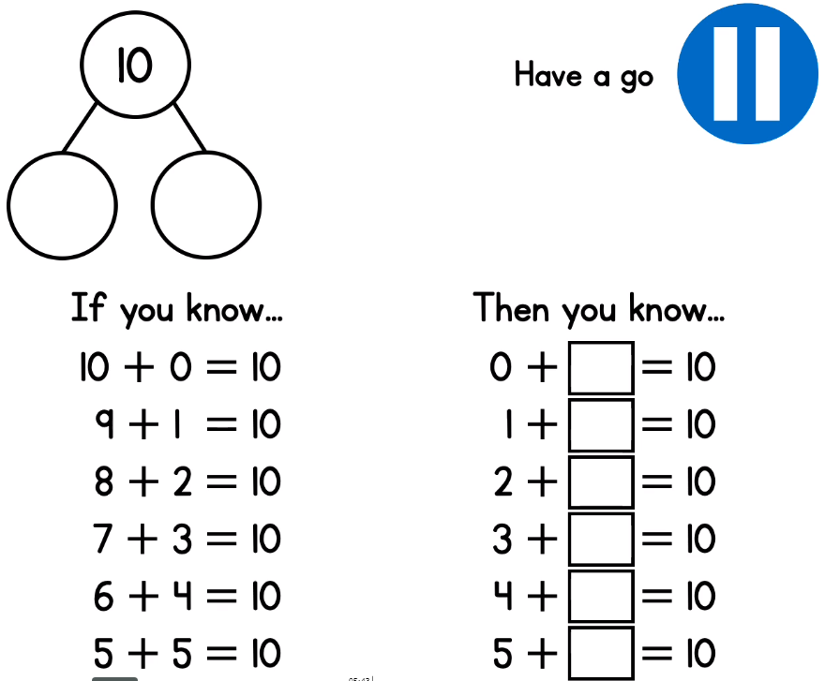

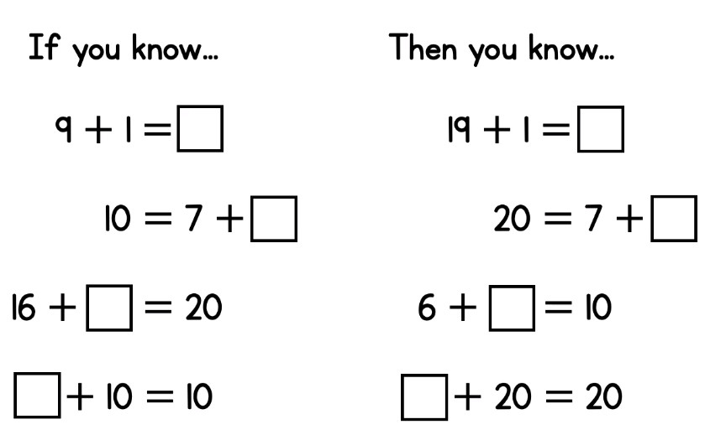
Section 2

Challenge
Use the ten frames/ part whole below to represent each of the calculations below.
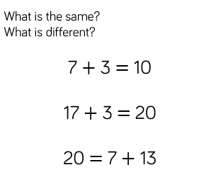

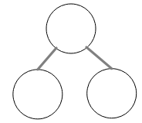
Creative
Design a maze!
Paddington Bear loves eating marmalade sandwiches. Can you help him find his way through the maze to the jar of marmalade.
Now try this one:
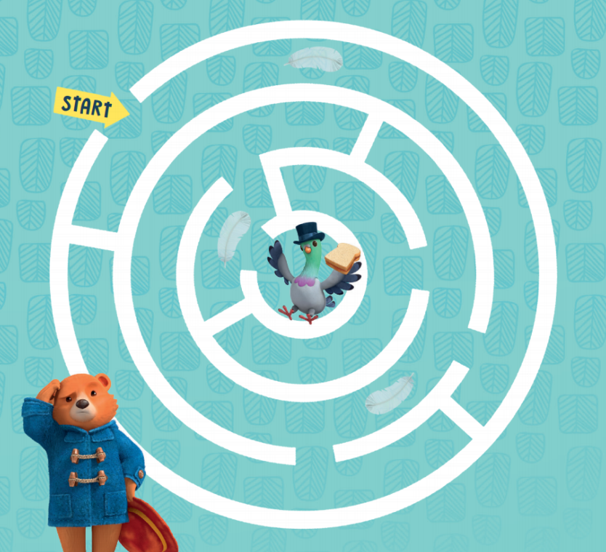
Can you have a go at drawing your own maze? Don’t forget to send us your creation!

Weekly Project work

The Four Seasons

We have learnt about the four seasons in Science this year: Spring, Summer, Autumn and Winter. Watch the video and discuss what you can see happening. Are there any changed in the weather? What is happening to the plants?

https://www.bbc.co.uk/teach/class-clips-video/the-changing-seasons/zh4rkmn

Task One
Draw a picture to represent each of the four seasons. Think about the colours you will use, what the weather will be like and what will/will not be growing at that time of year. Can you name each season and write a short caption underneath about what you may see.

Draw a picture and name the season.

Write a description of what you may see.
Task Two
Which season is it currently? I would like you to carry out an experiment and monitor the weather for the next week. You could complete the table below, or create one of your own.
I would also like you to find out how much it rains each day/if it rains during this season. Can you get a measuring jug and put it outside every day. The next morning, you can look at how much rain there has/has not been and record it in the table.

Day | Monday | Tuesday | Wednesday | Thursday | Friday
Weather
Amount of rain
Description

How much rain have you collected today?
Draw a picture of the weather

