English – exploring the duck
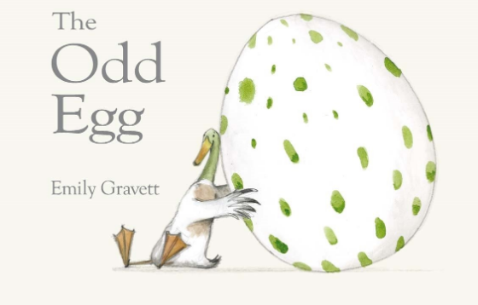

Now I would like you to read a bit more of the story up to 1:10 “All except for duck.” https://www.youtube.com/watch?v=rkI_i1hxAkI
Talking task
Can you take through what has happened in the story so far?
In the story…
The character have…
The characters feel…

Task One – discussion task

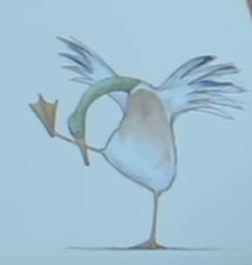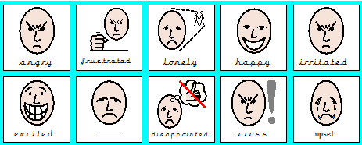
In the story, all the birds have an egg except for duck. How do you think he might be feeling? Talk through some ideas with a family member.
I think duck is feeling…
I think he should…because…

Task Two – sentence work

Using your ideas from the previous task, I would like you to write four sentences which describe how the duck is feeling at this point in the story. Your four sentences needed to:
- Be written in full sentences
- Use a capital letter and full stop
- Use finger spaces
- Challenge – use because to explain your reasons.

I think the duck is feeling…because…

Additional Task
What could you do to cheer duck up?
Maths
Follow the link to the White Rose website. https://whiterosemaths.com/homelearning/year-1/. Continue watching the video from yesterday (week 3, lesson 1 from 11.55 minutes).

Pause at 15.20 and complete this task.
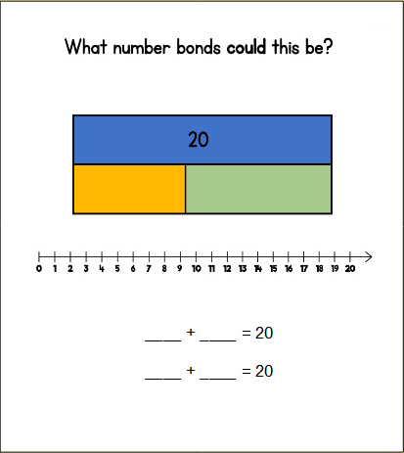

Watch the video to the end for the answers. Then complete the questions on the next two pages.
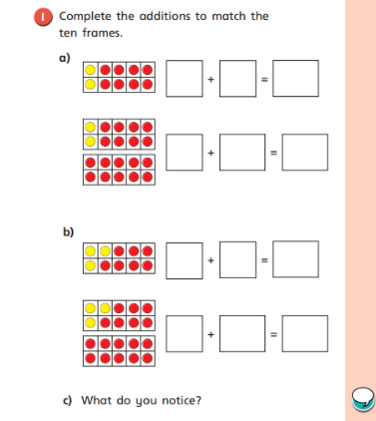

I notice that if _____ + ____ = _____, then _____ + _____ = _____.

I need to add _____ to one part to make _____.

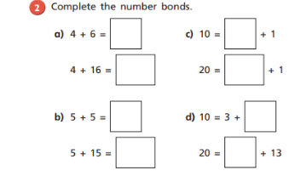
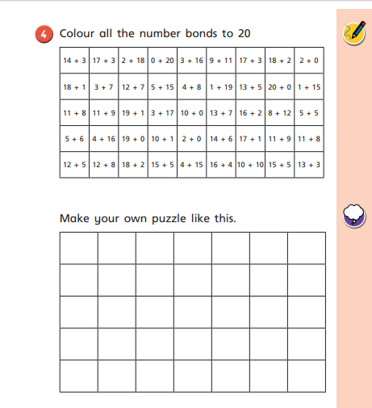
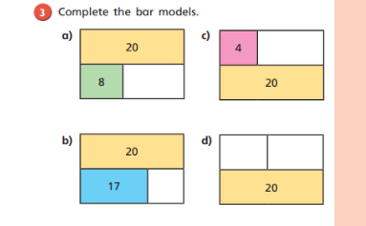

Creative
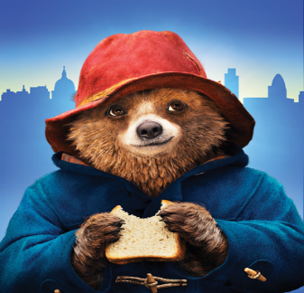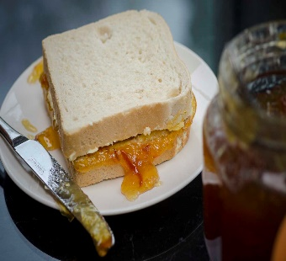
Can you design and make a new sandwich for Paddington Bear? What is your favourite sandwich filling? Here are some ideas:
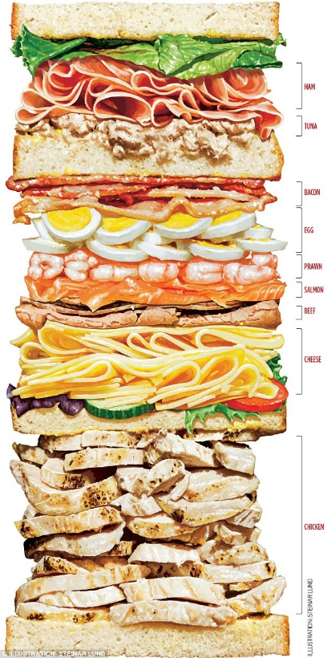
You will need:
- 2 slices of bread
- Butter
- Knife
- Plate
- Filling of your choice

How to make a sandwich:
Ask an adult to help you.
- Wash your hands with soap and water.
- Put 2 slices of bread on a plate. Spread a small amount of butter over each slice of bread with a knife.
- Prepare your filling.
- Spread your filling over the bread.
- Put one slice of bread on top of the other.
- Using a knife, cut your sandwich in half.

Weekly Project work

The Four Seasons

We have learnt about the four seasons in Science this year: Spring, Summer, Autumn and Winter. Watch the video and discuss what you can see happening. Are there any changed in the weather? What is happening to the plants?

https://www.bbc.co.uk/teach/class-clips-video/the-changing-seasons/zh4rkmn

Task One
Draw a picture to represent each of the four seasons. Think about the colours you will use, what the weather will be like and what will/will not be growing at that time of year. Can you name each season and write a short caption underneath about what you may see.

Draw a picture and name the season.

Write a description of what you may see.
Task Two
Which season is it currently? I would like you to carry out an experiment and monitor the weather for the next week. You could complete the table below, or create one of your own.
I would also like you to find out how much it rains each day/if it rains during this season. Can you get a measuring jug and put it outside every day. The next morning, you can look at how much rain there has/has not been and record it in the table.

Day | Monday | Tuesday | Wednesday | Thursday | Friday
Weather
Amount of rain
Description

How much rain have you collected today?
Draw a picture of the weather

