Y4 HOME LEARNING – Friday 10th July 2020

Comprehension Task

Read the reading task from yesterday, answer the questions below. Make sure you keep using the text to help you find the answers.

- Approximately how far is it in miles from England to Crete?

- “What a mess! It’s like a labyrinth in here!” How else could the author have written this line?

- How do you think Theo felt when he moved to Crete? Explain your answer.

- List three facts about the ballroom.

- Why do you think that Theo’s room was ‘filled with all sorts of ancient furniture’?

- Find and copy three words that the author uses instead of ‘said’.

- ‘Theo had been wandering round his bedroom for hours.’ Why do you think that this was the case?

- ‘His toy sword gripped firmly in his right hand, just in case.’ Why might Theo need to carry his toy sword?

- What do you think Theo will do next?

- Write a short summary for this story.

Maths - Friday 10th July 2020
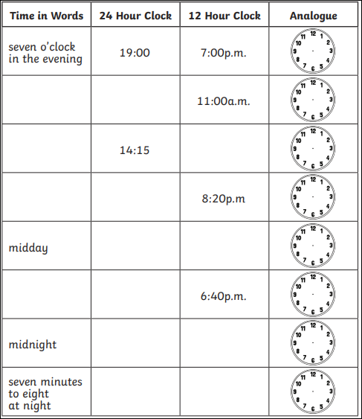
Converting Time
Morning past forty
Midday to fifty
Afternoon five a.m.
Evening ten p.m.
half fifteen minutes
o’clock twenty
quarter thirty

Creative Activity – Friday

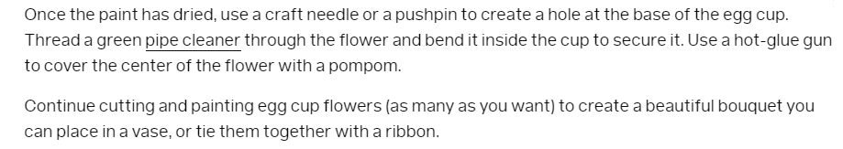
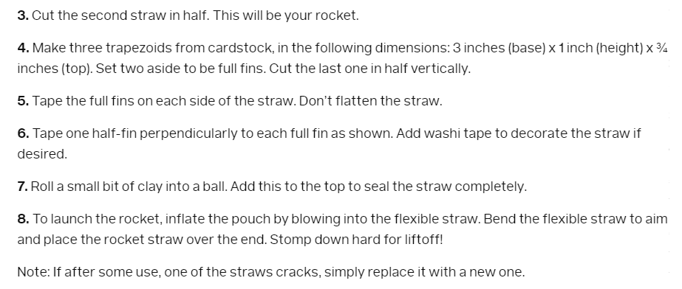
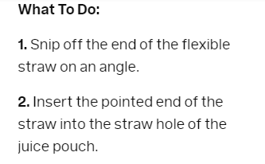
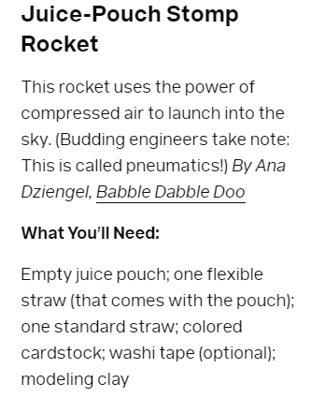
Juice-pouch rocket

