Tuesday
English
Adjective challenge
Look carefully at this picture.
Set a timer for 10 minutes.
Write as many adjectives as you can in that time – adjectives describe the different things that you can see.

Maths
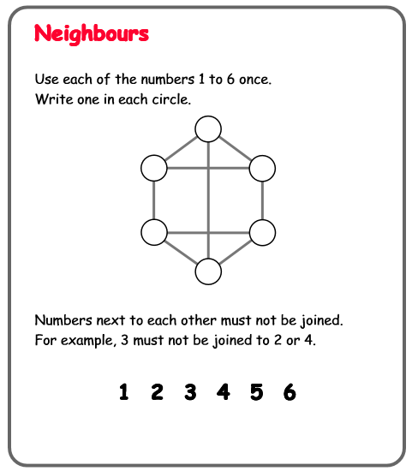

Creative Challenge!

Last week activities! 2
What has hatched from the egg? Draw your ideas!

