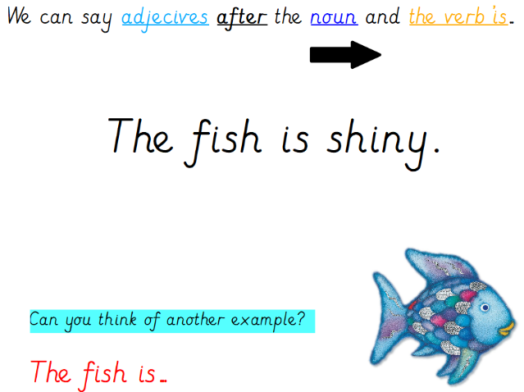
English – expanded noun phrases
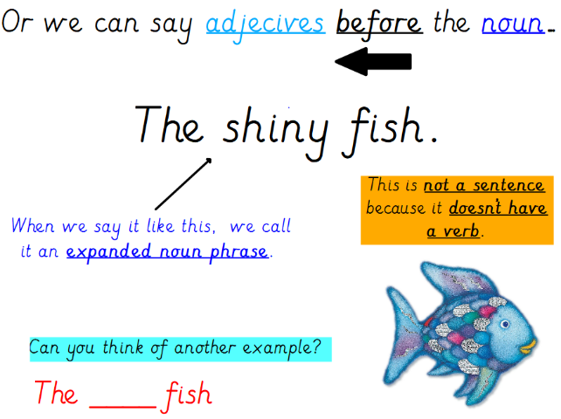

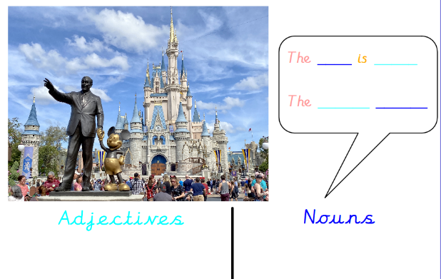

Which words and adjectives can you use to describe objects in this picture?

Complete these phrases to describe the animals in the pictures:
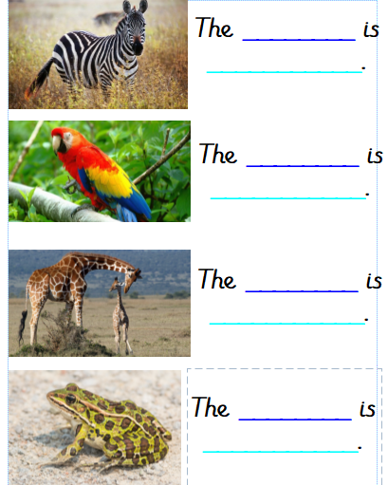
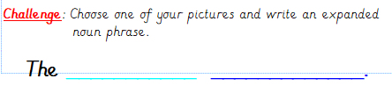

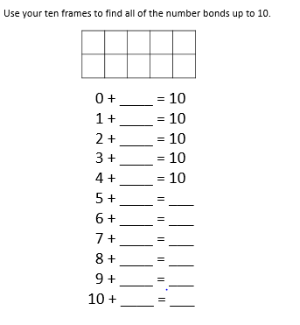
Maths

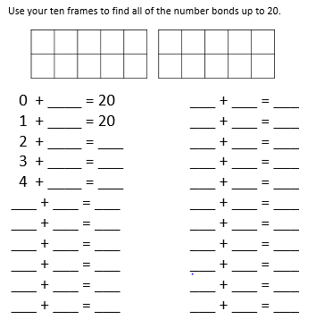

Creative
https://www.youtube.com/watch?v=D2-O1LkCzpM
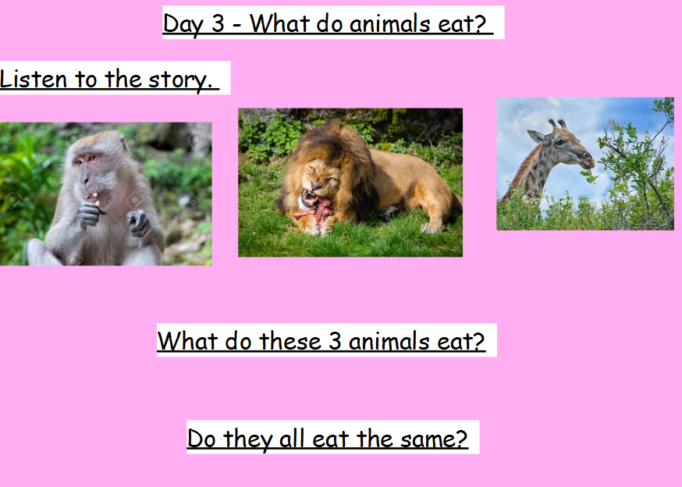
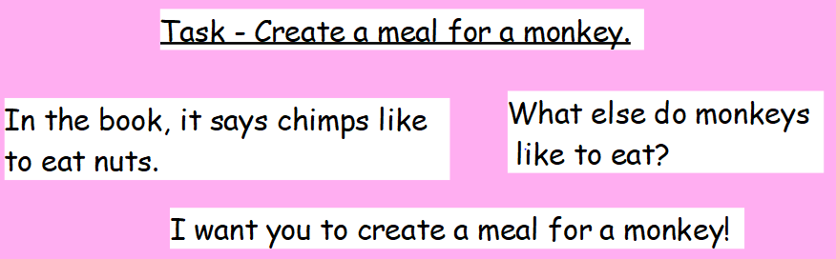

Weekly Project work

This week, we are going to be learning how to group animals based on what they eat. Watch this short clip and look out for the three key names that we use to group animals in this way.
https://www.bbc.co.uk/bitesize/clips/zwfd2p3
From watching the video, can you group the animals into the correct categories below?
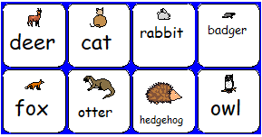
Herbivores | Carnivores | Omnivores

Play this game about what different animals like to eat: https://www.sheppardsoftware.com/content/animals/kidscorner/games/animaldietgame.htm

Complete this based on your new knowledge:
I am a _________.
I like to eat______________.
I also know that___________________________________________________
________________________________________________________________.

