 | Phonics/Literacy | Maths
Monday | Have a listen to our story of the week Walking through the jungle  https://www.youtube.com/watch?v=kUEw7ZReZL8  Can you draw your own animal pattern? | 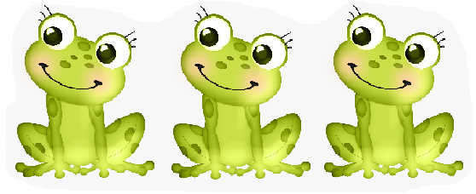  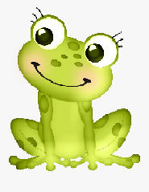  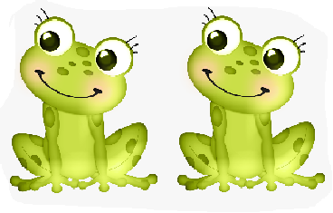 Count the frogs. Which picture has the most frogs?
Tuesday | Join in with this fun clapping game!  https://www.youtube.com/watch?v=exnmzJH8HgM  https://www.youtube.com/watch?v=anmcoVFcvc0 | Watch this video all about counting to 3!  https://www.youtube.com/watch?v=blBJfAb0Bbk
Wednesday | Have a go at making your own musical instrument with help from your grown up.  https://www.youtube.com/watch?v=BWJALMLziOQ  Can you sing a song with your instrument? | Have a go at writing numbers 1,2 and 3. Start on the red dot and follow the arrow.
Thursday | Watch the story again. Can you pretend to be the crocodile swimming, the monkey swinging, the tiger running, the lion leaping and the boy walking? | Watch number blocks and learn all about counting to 3!  https://www.youtube.com/watch?v=Bkufsme9qiA
Friday | Join in singing our jungle songs:  https://www.youtube.com/watch?v=t2jnqUyxck0  https://www.youtube.com/watch?v=GoSq-yZcJ-4  https://www.youtube.com/watch?v=5xDpjw1mwZM | Can you find 3 objects (count them to check) and put them in order from smallest to tallest?

