 | Phonics/Literacy | Maths
Monday | Using your hand, make your own handprint monkey!  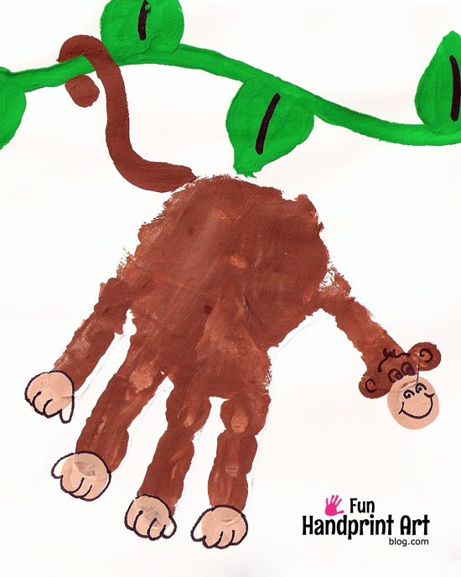 | Count the objects on the video:  https://www.youtube.com/watch?v=0WdB3mNGycQ
Tuesday | Have a look at the animals below. Can you remember which action the animal did in or story?  We had a Gorilla, Buffalo, Donkey, Camel, Penguin, Cat and Crocodile.  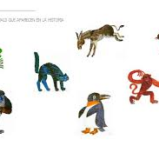 | Have a practice writing numerals 1-5.  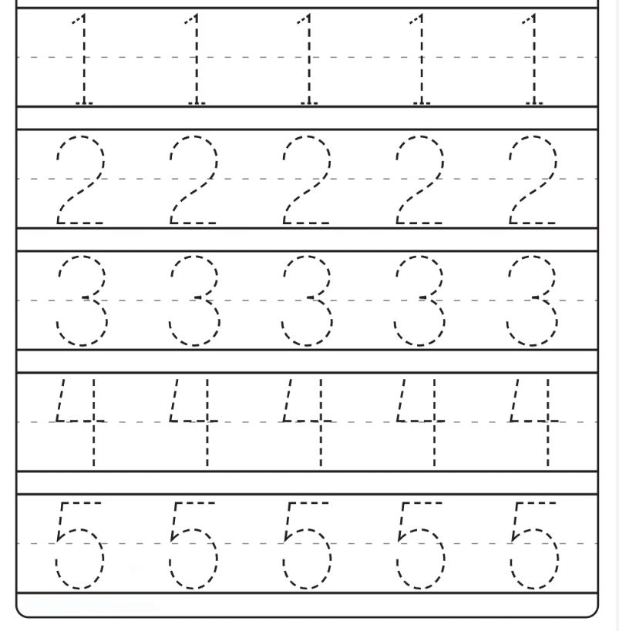
Wednesday | Have a listen to this body parts song:  https://www.youtube.com/watch?v=QkHQ0CYwjaI | Watch this video about matching numeral with the quantity.  https://www.youtube.com/watch?v=MD4Sk_CqIe8  Can you find objects to match the numeral 1, 2, 3, 4 and 5?
Thursday | Can you make your own Christmas card?  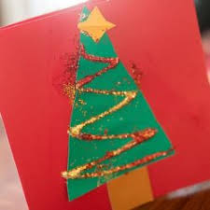 | Sing along to this song. Don’t forget to use your fingers to count how many ducks are left!  https://www.youtube.com/watch?v=pZw9veQ76fo
Friday | Have a try at writing your name. Don’t forget to warm up your fingers first:  https://www.youtube.com/watch?v=N6kPcQSSsEY | Can you do 5 claps?  3 hops?  2 jumps?  4 nods of your head?  1 stomp?  Can you find the numbers around the house?

