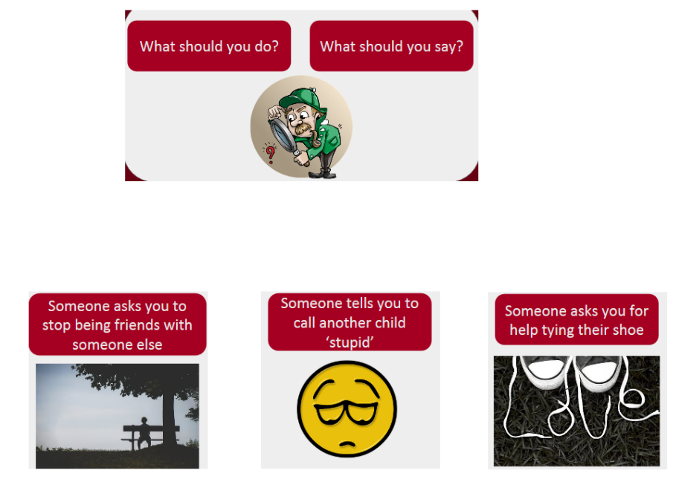

|  |  |  |
| --- | --- | --- |
|  | What should you do? | What should you say? |
|  |  |  |
|  |  |  |
|  |  |  |