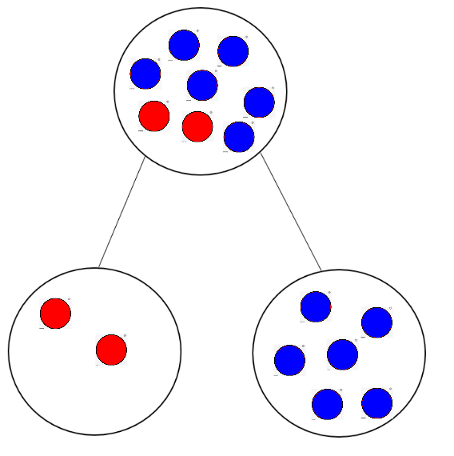
___ + ____ = ____

___ + ____ = ____

____ - ____ = ____

____ - ____ = ____

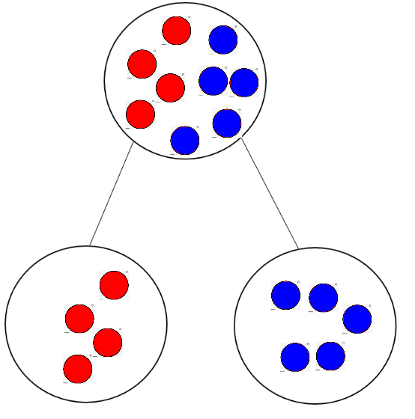
___ + ____ = ____

___ + ____ = ____

____ - ____ = ____

____ - ____ = ____

Jen
Tom
The difference is ____.
Beth
Jim
The difference is ____.
Laura
Sam
The difference is ____.
Kem
Liv
The difference is ____.
John
Sarah
The difference is ____.

 | What is the difference? | ___ - ___ = _____
 |  | _____ - _____ = _______
 |  | _____ - _____ = _______

- What’s the difference between 10 and 5?

___ - ____ = ____
The difference between 10 and 5 is _____.
- What’s the difference between 8 and 2?

___ - ____ = ____
The difference between 8 and 2 is _____.
- What’s the difference between 5 and 2?
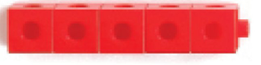

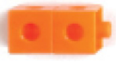

___ - ___ = ____
The difference between 5 and 2 is _____.
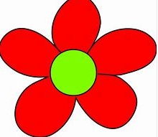
- What’s the difference between 6 and 4?
____ - _____ = ______
The difference between 6 and 4 is _____.
- What’s the difference between 9 and 3?
____ - ____ = ____
The difference between 9 and 3 is ____.

Circle the correct picture.
- The difference between 6 and 4 is 2.

- The difference between 7 and 2 is 5.

- The difference between 6 and 1 is 6.
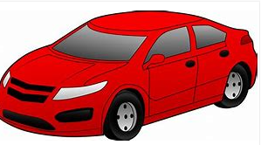
- 6 – 3 = 3
