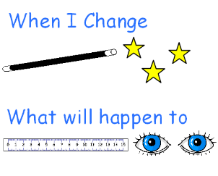
Title of Investigation
When I change the __________________________________, what will happen to _________________________________?

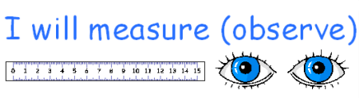
What are we trying to find out?
I want to find out if the ___________________________
______________________________________________________________________________

What will you keep the same?
My design

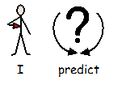
My prediction
I predict that the __________________________________
Will ___________________________________________________________
____________________________________________________________________

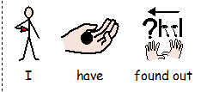
Results

