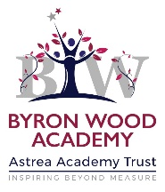


Remote education provision: information for parents
This information is intended to provide clarity and transparency to pupils and parents or carers about what to expect from remote education where national or local restrictions require entire cohorts (or bubbles) to remain at home.
For details of what to expect where individual pupils are self-isolating, please see the final section of this page.

The remote curriculum: what is taught to pupils at home
A pupil’s first day or two of being educated remotely might look different from our standard approach, while we take all necessary actions to prepare for a longer period of remote teaching.

What should my child expect from immediate remote education in the first day or two of pupils being sent home?

As a school we will provide access to Blended Learning Plans for Literacy, Maths and the curriculum available from the both the school website and the through the Astrea App.
The plans follow the objectives being delivered during the current term for each of the year groups covering the learning which children would have been experiencing in school.
In addition to the Blended Learning Plans there is a Foundation Curriculum Matrix which enables you and your child to select a variety of activities from the menu available. These are all related to the Foundation Subjects for each year group in school.
These can be recorded on paper, photographed or scanned and sent to your child’s year group email.

Following the first few days of remote education, will my child be taught broadly the same curriculum as they would if they were in school?

As a school we will provide a minimum of 4 hours teaching and learning time each day with additionalities throughout the week for the children to access. As the weeks continue we will be increasing our offer to best suit the needs of our children and families.
Here is an overview of our starting point and non-negotiables.
The 4 hours will be made up of the following:
- Daily Direct live teaching on screen using teams.
- Assignments set via Teams and on the school website which the children will be expected to complete either online, in a school work book or on paper.
- 1 x wider curriculum assignments set per day
- Directed time for children to complete the Blended Learning Plans created by individual year groups.
- Daily phonics for EYFS and KS1.
- Daily reading session for KS2.

Remote teaching and study time each day

How long can I expect work set by the school to take my child each day?
We expect that remote education (including remote teaching and independent work) will take pupils broadly the following number of hours each day:
EYFS | 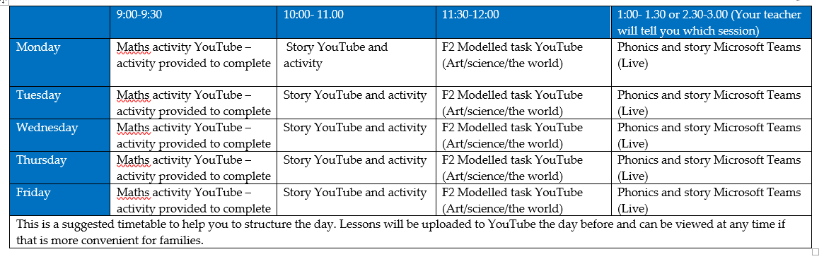
KS1 | 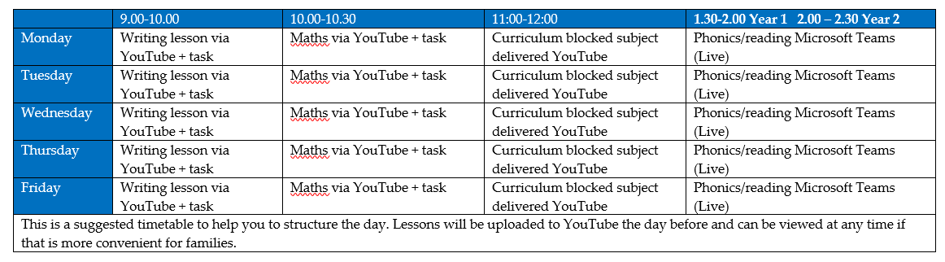
LKS2  Y3 & Y4 | 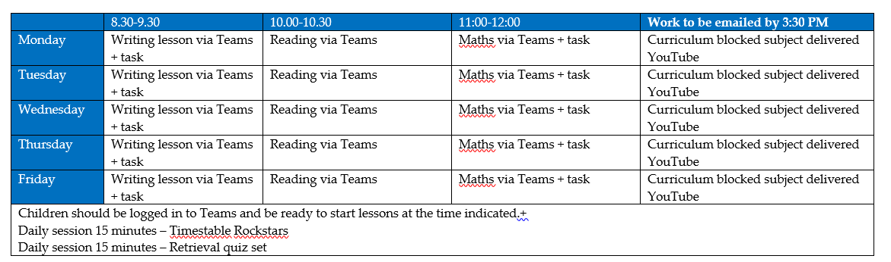
UKS2  Y5 &  Y6 | 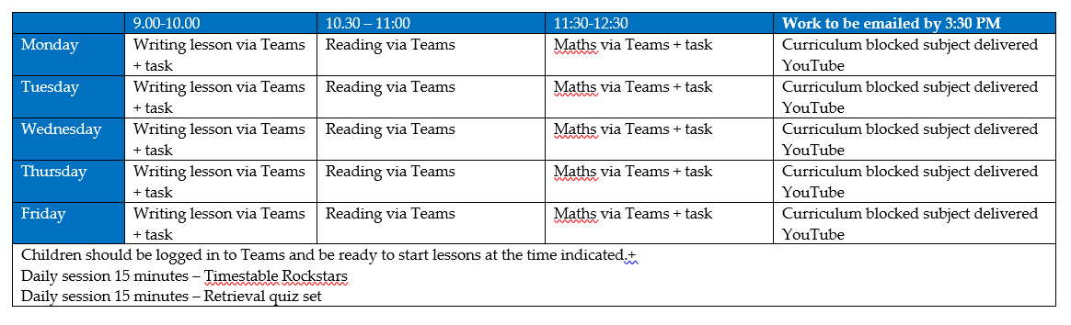

Accessing remote education

How will my child access any online remote education you are providing?
Live Teaching using Teams.
2 x 30 min sessions and 2 x 30 min activities
Each day, all year groups from Y3-Y6 have been allocated 2 x 30-minute teaching slots. Y1 and Y2 have 1 slot, day depending. One 30-minute slot is for an English session and one for a Maths session. Once these sessions have ended, children will be directed to the ‘assignment’ which will be allocated to them on Teams or through the website. Children will either complete this virtually and send back, or complete in work books or paper which can be provided by school if required. This is crucial as it gives us the ability to track who is taking part and completing the learning set. For those children who cannot edit and return assignments online, there will be an expectation that evidence from these sessions is collected in when children have returned by bringing work books into school or by emailing the work to the class email.

Assignments
1 x assignments per day linked to the wider curriculum
Using the Teams App, you can set individual assignments for your class. Each day we will provide 1 x assignments linked to the wider curriculum. These again, should be no more than 1 A4 page. These activities will be purposefully planned to support those children who will be completing the activity in a work book or online.

Independent Learning time
We have the expectation that the children will work independently for 1 hour per day. The children will use the Blended Learning Plan which have been put in place as a school. These are tailored to each individual year group and cover the English, Maths and the wider curriculum objectives that would have been taught during the Spring term.

NearPod
NearPod is an interactive website that provides online teaching and learning resources. These are done through interactive slideshow presentations. Each member of staff will register and make an account. Teachers will let your child know when they need to search the NearPod library for resources which link to your current learning or you can make your own slideshows or quizzes. You then send a request for children to join via Teams to the children, selecting the ‘Student Paced’ option. This means children can access these resources.

If my child does not have digital or online access at home, how will you support them to access remote education?
We recognise that some pupils may not have suitable online access at home. We take the following approaches to support those pupils to access remote education:
- A family survey was conducted in December 2020 to ascertain what IT hardware families had available to them – from this a spreadsheet was generated to allow us to order laptops, 4G dongles and tablets to support home online learning. If you did not complete that or think your circumstances have changed please contact school who will be able to assess the needs you have for remote learning and can formulate a plan to look at how these needs can be met
- These devices will be issues to the named identified families with guidance documents relating to the use of the devices
- If you are unable to access learning through electronic means a learning pack can be supplied with books, paper and pens for work to completed
- If you are unable to access learning through electronic means work can be completed on paper photographed and emailed to an identified school email account for submission
- If work is being completed electronically this can be submitted using the ‘Turn In’ function on Teams

How will my child be taught remotely?
We use a combination of the following approaches to teach pupils remotely:
Here are some examples of remote teaching approaches we will be using at the school:
- Live teaching (online lessons)
- Recorded teaching (video recordings made by teachers)
- Printed paper packs produced by teachers (e.g. workbooks, worksheets)
- Textbooks and reading books pupils have at home
- Access to Times Table Rock Stars
- Blended Learning Plans which follow the current terms objectives
- Home Reading

Engagement and feedback

What are your expectations for my child’s engagement and the support that we as parents and carers should provide at home?
School Expectations:
- Children in KS1 are expected to undertake 3.5 hours learning per day and KS2 are expected to undertake 4 hours learning per day. This will involve a mixture of online live teaching, online assignments and quizzes – initially this will require adult support to access but we expect children very quickly to be able to use the Teams tools well. As the teacher will be delivering the direct input required to complete the assignments and quizzes the children should not require any additional adult input but just support from families to complete the learning activities
- All assignments should be completed and returned to the class teacher using the ‘Turn In’ button on Teams
- Weekly feedback will be provided to all children and families through weekly phone contact which will be an opportunity for families to clarify any learning points and to gain and understanding of how their child has achieved
- Feedback will also be provided in the follow up lessons

How will you check whether my child is engaging with their work and how will I be informed if there are concerns?
- Weekly feedback will be provided to all children and families this will be an opportunity to discuss any challenges which families may have experienced in accessing learning and to understand why your child has not been able to engage with the learning provided
- All online activity will be tracked through Insights on Teams – this allows the teacher to be able to track what activities the children have completed and engaged with as well as which live teaching sessions they have attended

How will you assess my child’s work and progress?
Feedback can take many forms and may not always mean extensive written comments for individual children. For example, whole-class feedback or quizzes marked automatically via digital platforms are also valid and effective methods, amongst many others. Our approach to feeding back on pupil work is as follows:
- Direct question and responses during the live teaching - daily
- NearPod learning activities - weekly
- Quizzes which provide immediate feedback - daily
- Weekly teacher family feedback conversations by telephone

Additional support for pupils with particular needs

How will you work with me to help my child who needs additional support from adults at home to access remote education?
We recognise that some pupils, for example some pupils with special educational needs and disabilities (SEND), may not be able to access remote education without support from adults at home. We acknowledge the difficulties this may place on families, and we will work with parents and carers to support those pupils in the following ways:
- All children with an EHCP (Education Health Care Plan) will be allocated a place in school where the can continue to work not only on the curriculum objectives relevant to them but also on the personalised learning objectives set out in their EHCP enhanced by the additional support identified from within school
- Any pupil requiring support which is additional to and different from that of any other child in the same year group will receive a personalised learning pack to complement and support the online learning experience. This will contain useful support tools that will aid with the remote and online learning
- The SENDCo (Special Educational Needs Co-ordinator) will be observing remote teaching sessions in every year group and will be able to feedback to the teacher to guide and advise of any tweaks or adjustments which could be made to support the learning of pupils who may find it more challenging to access the remote learning
- Weekly conversations will take place with all families and if required a follow up call from the SENDCo to advise of any specific measures and support which can be put in place to enable learning to be both purposeful and positive
- Individual work may be sent to the children through email

Remote education for self-isolating pupils
Where individual pupils need to self-isolate but the majority of their peer group remains in school, how remote education is provided will likely differ from the approach for whole groups. This is due to the challenges of teaching pupils both at home and in school.

If my child is not in school because they are self-isolating, how will their remote education differ from the approaches described above?
If your child is self-isolating and still well enough to access the remote learning through the weekly planned schedule they should do so. If your child is unwell and not able to access the online learning you will need to make school aware of this so any adjustments can be made for example recording the live teaching session and making it available for you at a later date. All other resources and tasks will still be available online at the point when your child is well enough to access them.

