13.1.21
L.O. To know what humans need to survive.
Success Criteria | P | T
I can explain what survival means.
I know what the 3 basic needs are.
I know what else is important to live safely and healthily.
I know what humans do not need to survive.

We need this to survive | This is important for us to live safely and healthily. | These are not important to survival.

water | friends | shelter
sleep | food | computers
cars | air | exercise

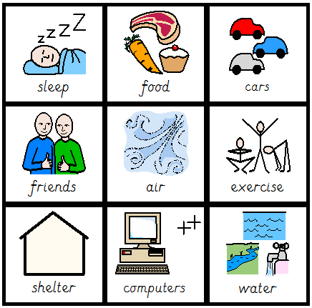

Statement | True or False?
We need to play with friends to survive.
Humans will not survive
without food.
All animals have 3 basic needs.
Sleep is a basic need.
Humans can survive without
shelter.

