 | Phonics/Literacy | Maths
Monday | Watch Goldilocks and the 3 bears story:  https://www.youtube.com/watch?v=0oUP2PFeOi8 | Find 3 objects and put them in order from smallest to biggest!
Tuesday | Have a listen to our story again.  Can you join in with the familiar phrases? | Watch number blocks. Can you join in with the counting?  https://www.youtube.com/watch?v=kak7S7zC604
Wednesday | Make your own bear mask. Can you remember what happened to baby bears chair? What did he say?  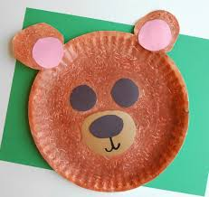 | Find 6 objects, e.g teddies, pencils etc. Add 1 more, now how many do you have? Count them to check.  Try again, but this time, take 1 away.  Keep practicing  Watch this video to help:  https://www.youtube.com/watch?v=Du6JHupzwVo
Thursday | Watch alphablocks:  https://www.youtube.com/watch?v=s7LjGDcXqcs | Practice writing the number 6!  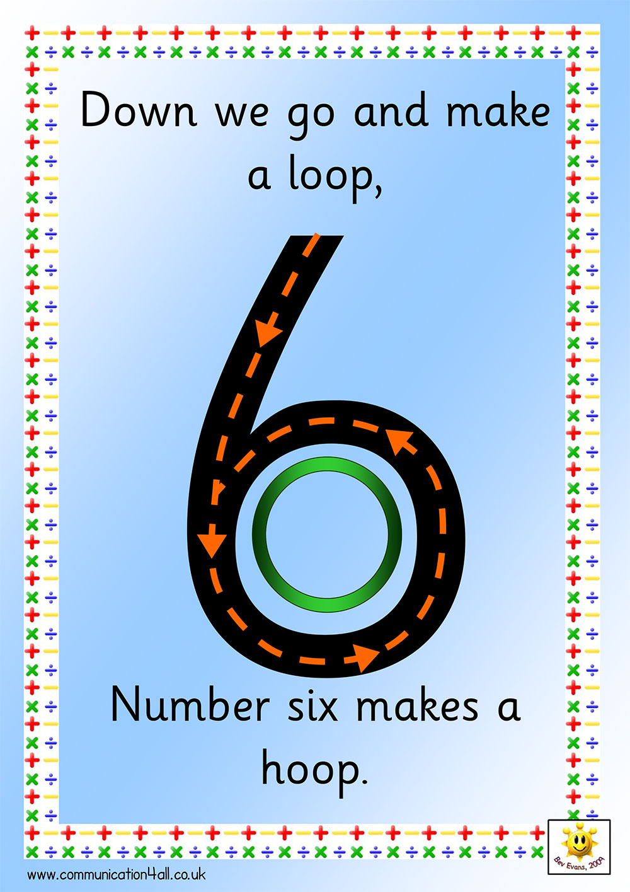
Friday | Have a try at writing your name. Don’t forget to warm up your fingers first:  https://www.youtube.com/watch?v=N6kPcQSSsEY | Have a look in your house/outside.  What different shapes can you see?  Count how many circles/rectangles and squares that you see.  Watch this to help:  https://www.youtube.com/watch?v=mYtEmJ2TzOQ

