Friday’s English
Task One – label what Beegu can see, hear, touch and taste
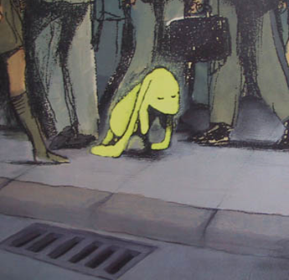

Task two
Object | Action + -ing
dog | barking

